

School of GeoSciences

Dissertation
For the degree of

MSc Environment and Development

María Rodríguez Beperet

August 2014

Policies for whom?

Realities of the Romanian peasantry beyond the Common Agricultural Policy

Statement of originality

I hereby declare that this dissertation has been composed by me and is based on my own work.
María Rodríguez Beperet

Word count: 17471

Abstract
Since its origins in 1962, the Common Agricultural Policy (CAP) has been a keystone of the European political framework. Conceived to support agriculture and rural development, this policy has followed two major trends: it primarily promotes the modernisation and competitiveness of agricultural production, and secondly it claims principles of sustainability and diversification. Beyond that, I consider the CAP needs to be examined, a deep analysis of the rationale and underlying interests driving this policy is undertaken in this study. I argue that this package is deeply rooted within Western parameters and, as such, does not necessarily pertain to the specific circumstances regarding the East-European New Member States (NMS); ex-communist and in-transition countries such as Romania, the country selected to exemplify this research. The CAP might be seen as another project of modern (rural) development and hence, neo-liberal expansionism. The realities of the local communities are not taken into account, thus promoting inaccurate solutions. The need to ascertain the particularities of the Romanian peasantry is tackled here through a case-study ethnographic research. It seems that, even when the target is placed on sustainability and local development, Western criteria and interests are superimposed. These external impositions might add pressure to rural livelihoods and lead the peasant world into a vulnerable position.

Acknowledgments
I want to dedicate this dissertation to my parents, who have believed on me more than myself. Ama, aita, bai modu, beti gurekin.
I am especially grateful to my supervisor Dr. Kanchana N. Ruwanpura, whose tranquillity and advice have supported me since the beginning of the year.
This research owes everything to the people from Comuna and Timisoara. Farm owners, thank you for hosting and giving me the chance to discover new and fantastic worlds. Xela, Anadnav, and both of your extended families; Oigres and Inohs; the lawyer, and all the goatherds, shopkeepers and random people who have had the benevolence of accepting me around; mulțumirile mele sincere. You have given a young woman the chance to learn and experience other ways of living.
Finally, brief but not least, many thanks to all my proof-readers. And a big clap to my Ecuadorian girl and my favourite Italians. Brava, kala!

Table of Contents

1. Introduction 1
Chapter 2. Literature review and theory 6
2.1 The logic of the CAP 6
2.2 The logic behind the CAP 8
2.3 The CAP models of rural development 12
2.4 The context of Romania 17
Chapter 3. Methodology 21
3.1 Why Participant Observation? 21
3.1.1 On the field 23
3.1.2 Issues to acknowledge 26
3.2 Photographic material 27
3.3 Further ethical considerations 29
Chapter 4. Comuna from the grounds 31
4.1 Where time converges 33
4.2 Work, social ties… and more work 39
4.3 A thriving community 44
Chapter 5. Discussion 51
5.1 Diversification and “mutifunctionality” 51
5.2 “Relocalisation” and social ties 55
5.3 Politics and interests 59
5.4 Final remarks 61
Chapter 6. Conclusions 63
Appendices 66
References list 75

List of Photographs
Photograph-1……………………………………………………………………………………………………………………32
Photograph-2……………………………………………………………………………………………………………………32
Photograph-3……………………………………………………………………………………………………………………34
Photograph-4……………………………………………………………………………………………………………………34
Photograph-5……………………………………………………………………………………………………………………34
Photograph-6……………………………………………………………………………………………………………………35
Photograph-7……………………………………………………………………………………………………………………35
Photograph-8……………………………………………………………………………………………………………………36
Photograph-9……………………………………………………………………………………………………………………36
Photograph-10…………………………………………………………………………………………………………………36
Photograph-11…………………………………………………………………………………………………………………38
Photograph-12…………………………………………………………………………………………………………………38
Photograph-13…………………………………………………………………………………………………………………39
Photograph-14…………………………………………………………………………………………………………………39
Photograph-15…………………………………………………………………………………………………………………40
Photograph-16…………………………………………………………………………………………………………………40
Photograph-17…………………………………………………………………………………………………………………41
Photograph-18…………………………………………………………………………………………………………………41
Photograph-19…………………………………………………………………………………………………………………42
Photograph-20…………………………………………………………………………………………………………………43
Photograph-21…………………………………………………………………………………………………………………44
Photograph-22…………………………………………………………………………………………………………………45
Photograph-23…………………………………………………………………………………………………………………46
Photograph-24…………………………………………………………………………………………………………………47
Photograph-25…………………………………………………………………………………………………………………48
Photograph-26…………………………………………………………………………………………………………………48
Photograph-27…………………………………………………………………………………………………………………48
Photograph-28…………………………………………………………………………………………………………………48
Photograph-29…………………………………………………………………………………………………………………48
Photograph-30…………………………………………………………………………………………………………………48
Photograph-31…………………………………………………………………………………………………………………49
Photograph-32…………………………………………………………………………………………………………………49

List of Figures, Maps, and Tables
Figure 1.1: Ultimate goal and main objectives………………………………………………………………………4
Figure 2.1: Current structure of the CAP……………………………………………………………………………….7
Map 3.1: Arad and Timisoara………………………………………………………………………………………………25
Table 3.1: Overcoming Chamber’s biases…………………………………………………………………………….29

List of Acronyms

AFN Alternative Food Networks
CAP Common Agricultural Policy
EAFRD European Agricultural Fund for Rural Development
EAGF European Agricultural Guarantee Fund
EEC European Economic Community
EU European Union
FSC Food Supply Chains
LEADER Liaisons Entre Actions de Développement de l’Économie Rurale
LFA Less Favoured Areas
NMS New Member States
NPRD National Program for Rural Development
PDO Protected Designation of Origin
PO Participant Observation
SAPS Single Area Payment Scheme
SFS Small Farmer Scheme
SPS Single Payment Scheme
UK United Kingdom
WB World Bank
WTO World Trade Organization

1. Introduction
“The agents of actual social life have to achieve something that affects their world.”
(Gray, 2000:48)
Talking about policies, it should be acknowledged that, beyond the regulations that arise in large institutions, there are human realities that need to be taken into account. It seems common to ignore the fact that, beyond the scripts, there are flesh and blood people that have a life to sustain. Individuals with their own contexts, necessities, interests and possibilities; in terms of Escobar (2012), different subjectivities. However, these are often hidden behind macro-structures and global synergies. If we centre on rural development, as it is the main focus of this dissertation, we should consider the words of Franz Fischler (in Sîrbu, n.d) “it is about real rural futures for real rural people”.
In the European Union (EU), in terms of agriculture and rural development, the European Commission (EC) claims the Common Agricultural Policy (CAP) as THE policy – see for example EC (2012a) or Alexandri (2012) – purposing (rather imposing, as we will see) a package of measures that, at first glance, could be seen as coherent and sensibly conceived. The CAP has been, and is still, a keystone within the European political framework (Hubbard and Gorton, 2011). Nevertheless, things need to be reconsidered rather than being reproduced by inertia. As it happens, within the CAP, there are embedded questions that should be taken into account; issues that have an underlying cause, and broad effects.
In 2007, Romania entered the EU. As a New Member State (NMS), “accession would be conditional on meeting criteria defined by existing Member States; […] it was the task of applicant states to adapt to European Union policy structures” (Gorton, Hubbard and Hubbard, 2009:1306), implementing the Acquis Communautaire, the European Union legislative corpus (Grabbe in Gorton et al., 2009). As such, Romania had to integrate the CAP in its National Plan for Rural Development (NPRD). Nevertheless, the CAP measures are not context-specific; they are applied within a “fixed menu” all around the EU (Gorton et al., 2009; Rusu and Florian, n.d), according to the interests and principles defined by the old EU members, ultimately Western European countries. It could be argued that, to integrate Western European legislation means consequently assimilating Western imaginaries, and eventually lifestyles. The CAP might be seen as another form of Western enlargement (Gorton, et al., 2009) or “Europeanisation” in terms of Ansell (in Camarero, Hernández and San Martín, 2007). Nevertheless, East European countries have their own context. Their strong rural stratum (remarkable compared to that of Western Europe) may not fit into the CAP parameters and requirements (Macken-Walsh and Curtin, 2013).
The CAP current dual agenda, agricultural efficiency alongside with sustainable diversification, and its constant reforms prevent academics from agreeing on the character and outcomes of these European policies. The issue of the CAP is complex, and its rationale should be questioned. From my perspective, and which is supported by authors such as Chambers (1983 and 1997) and Gray (2000), we are outsiders making judgements about the rural world; and our intervention influences people’s livelihoods. If strategies, programmes or projects such as the CAP are about to be developed, the less we should do is to gain proper, real and grounded knowledge about the targeted society. To focus on the reality of existent people (Geertz, 1973; Escobar, 2012) rather than blurring individuals into macro-structures and naturalised globalist trends (Peet and Watts, 1993) – although, having present the “combination of local and global forces, reacting at different junctures” (Voiculescu, 2008:87); – and avoid imposing implicitly or explicitly, and voluntarily or unwittingly ethnocentric values (Bernstein, 1971; Chambers, 1987); or what Peet (2002) would call “the hegemonic discourse”. For instance, currently popular notions of sustainability might not be considering non-Western realities, as we will see.
In these terms, I felt especially interested on an ethnographic approach. I believe that unless we understand the real live, any judgement and even less any action cannot be accurate. Rural Romania was the selected territory for my research. As a NMS of the EU, and as an ex-communist country, its locus might be of interest. Likewise, its especially rural character makes the country worthy of research in terms of agriculture and rural development. Furthermore, carrying the preliminary literature review, I was only able to find three articles which were straightforward related to the quotidian activities of the Romanian peasant (Kligman, 1984; Geana, 2006; Juler, 2014). This gap reflects a need to further understand Romanian rural society from the grounds.
With regards to the previously mentioned European policy, my interest on the real logic of the CAP goes back several years. When I was younger, a woman from the north of Spain told me that the farmers make their living from the CAP. What is the point of subsidising agriculture instead of paying fair prices to the farmers’ produce, so they can make their own living? I thought. As Sutton and Anderson remind us “virtually all contemporary cultures are dependent on agricultural products” (2004:174). Hence, why has farming been somehow devalued? When and why did it “became a ‘last instance employer’” (Kereker, 2010:47)? Using Polanyi’s words, I consider agriculture as the “basis of life” (in Hall, Hirsch and Li, 2011:9), and anything but an easy job; thus, it should not be relegated as it is and being subsidised to compensate this. Therefore, my interest on the rationale of the CAP has been maintained throughout the years. Below I state the ultimate goal and objectives of this dissertation.
Figure1.1: Ultimate goal and main objectives
Ultimate goal: Analyse whether the CAP matches with Romanian rural reality.

Source: own elaboration
Due to the character of this research, I have chosen a participant observation method coupled with photographic material. In order to complement and give theoretical grounds to my study, a fairly extended literature review has also been carried out. My methodology will be extensively described in Chapter 3. Nevertheless, I want to highlight that, since this research is based on my personal experience during no more than one month’s field endeavour, in a specific area and obviously limited number of participants, it is not my intention to overgeneralize my findings. However, I am glad to say that the chosen methodology has given me certain insight of the Romanian peasantry and I expect this might help others to gain an overview of it, and learn the importance of really knowing, and even experiencing first hand.
This dissertation is structured as follows. Chapter 2 gives an overview of the CAP and tries to highlight some of the underlying realms of this European policy. Thereafter, the models of rural development that the CAP promotes are introduced along with some of the debates that they generate. To conclude this chapter, I focus on rural Romania and the implementation of the CAP in this country. Chapter 3 describes the followed methodology. I justify why I chose a participant observation method. Subsequently, I explain how I have proceeded on the field and comment on delicate issues that needed to be addressed in this research. Finally, I recall on my use of photographic material, and how I have tried to avoid typical biases researching rural development while being ethically sensible. Chapter 4 presents the case study in Comuna (rural Romania). I present my findings by defining remarkable topics along with what I consider the most relevant photographs, and add pertinent comments within the images, in order to give additional information and provide to the reader with a narrative and cohesive sense of the photography. Chapter 5 further discusses about the main topics presented in the previous chapters, using real examples from my fieldwork. Finally, Chapter 6 concludes.

Chapter 2. Literature review and theory

2.1 The logic of the CAP
The CAP was implemented in Western Europe in 1962, where after the war period, concerns about the stabilisation of the market, food supply, and the welfare of the farmers became main concerns; and hence, the CAP principal targets (Martin and Mesias, 2002; Alexandri, 2013). According to the European Commission (EC, 2012a), since its origins, the budgetary percentage for the CAP has never been below the 40% of the total European budget; passing periods of great expenditure. For instance, in 1970 it reached 87% of the European total budget (EC, 2012b; BBC, 2013). Nevertheless, a steady reduction has been visible over the years (EC, 2012a; BBC, 2013; Alexandri, 2013), which is due to the evolution of this policy.
Originally aimed to regulate the European market through price intervention, the taxation of cheap imports in order to maintain internal agrarian prices, and the subventions to exports when world prices were lower than within the European borders (EC, 2012b) rapidly increased the CAP expenditures. These were incremented by payments to farmers to incentivise productivity. Notions of European agricultural self-sufficiency were initially central (Oliva, 1997; Bowler, 1992), and in these terms, it seems that the CAP was successful. The EU “became one of the great agricultural powers of the world” (Alexandri, 2012:15). Food security appeared guaranteed in Europe (Alexandri, 2012), generating even oversupply (Bowler, 1992; Martin and Mesias, 2002). Therefore, surpluses and expenses became a problem during the first years of the CAP. Thereafter, measures such as the land “set-aside” – which gave subventions to farmers under the condition of withdrawing land from cultivation (Bowler, 1992; Martin and Mesias, 2002) – tried to reduce the oversupply. Furthermore, farmers’ subsidies stopped being related to production and instead correlated to farm size (decoupling measure), this payment per hectare is known as SAPS (EC, 2012b). In terms of market control, already from 1994 the World Trade Organization tried to restrict agrarian European protectionism (Alexandri, 2013; EC, 2012b). Over the years, the CAP opened its market and production started to be allowed to respond to the market demands (EC, 2012b), therefore reducing institutional costs. Other reforms took place during the last decades, promoting new payments and measures towards new targets. The CAP structure can be seen in the figure below.
Figure 2.1: Current structure of the CAP
Source: own elaboration
Since the “Agenda 2000” the CAP defined two major pillars, which reflected a wider and dual focus: one that remained strictly related to agricultural economic support and a second that addressed broader measures towards rural development. Pillar II “Rural development” pursues the diversification of economic activities beyond the purely agricultural sense in rural areas. It also supports agri-environmental measures, related to sustainable production, and local development schemes. Over the years, the focus of the CAP turned from the “quantity” to the “quality” of products (EC, 2012b); insinuating higher interest on sustainability and small farmers rather than intensified agriculture. In an attempt to avoid the favouring of agribusinesses, the new reform of 2013 for the period 2014-2020 proposes certain measures such as delimiting (capping) the maximum payments to large farms (Alexandri, 2013). By applying “modulation” these surplus funds would be transferred to Pillar II (Martin and Mesias, 2002), which appeared to gain further relevance, potentially indicating a different CAP paradigm. Furthermore, from January 2015 “Cross Compliance” will make some of the voluntary agri-environmental measures (Pillar II) compulsory if direct payments (Pillar I) want to be received (EC, 2013). Hence, giving to sustainability further relevance and probably blurring the currently clear division between both pillars. But in which way does all this actually deal with the peasantry? – For further information about direct payments see Annex I, and to consider Pillar II measures, Annex II; for detail in the evolution of this policy see Annex III).

2.2 The logic behind the CAP
Rural areas are usually regarded as marginalised regions, which are especially vulnerable to poverty (Chambers, 1983). Rural spaces appear to vanish below the urbanisation and industrialisation process (Bernstein, 1971). The depopulation of these areas in favour of the cities is currently a global trend – in 1961, the world’s rural population represented 66% of the total whereas in 2013, this percentage decreased to 47% (World Bank database). The rural world seems a “residue” in the 21th century (Salazar, 1996). Governments worldwide have started to develop different strategies towards re-enhancing the decaying countryside, essentially in line with McNamara’s statement that “rural development is a strategy designed to improve the economic and social life of […] the rural poor. It involves extending the benefits of development to the poorest among those who seek a livelihood in the rural areas” (1975:3). Rural development appears to promote economic growth, and modernisation seems to become its major ally (Bernstein, 1971; McNamara, 1975; Chambers, 1983; Camarero et al., 2007; Hubbard and Gorton, 2010). The EU with its CAP is one of these examples.
It is however, ironic that modernisation is regarded as the solution to the declining countryside. It is precisely modernity, understood and promoted from a capitalist Western paradigm, that destroys the traditional rural society; “peasant societies are transformed by the introduction of market relations” (Bowler 1992:19). In the agricultural domain, modernisation is at the foundations of the “commercialisation theory”, which states that modern neo-liberalism no longer leaves space for traditional, small, and subsistence farming in the globalised world, considering it an “inefficient” agent (Bowler, 1992:89). In terms of Li (2011), the peasant becomes “people whose labour is not needed by the global capitalist system” (2011:281). Societies with an important agrarian structure, such Romania, are thus threatened under this system; not per se but because of the neoliberal macro-structure that regulates and reshapes the world.
Despite this free-market global order; states’ intervention in the agricultural domain (traditionally quintessential economic activity of the rural areas) is still notable. Peet and Watts remind us that “neoliberalism rarely jettisons the state entirely” (1993:233), and; according to Bowler, this entails interests (1992). European institutions are in charge of displaying the CAP payments (disguised subsidies as some consider) for example, and national states are responsible for allocating them. These payments are currently grounded on the idea that, without subventions, the small farmer is condemned to disappear – as we have seen, capitalist modernity condemns her/him – therefore, the protective character of the CAP might be discussed, as Potter and Tilzey (2005) do. What is the underlying interest on paying subsidies to farmers? It could be asserted that this is because, if rural areas and rural people do not adapt to the parameters of modernity, if they do not respond to neoliberal interests or requests, then they are not only non-functional for the system; they become a problem. Claims such as that made in an EC’s report about the CAP, which states that “the farmers are a very important economic agent in the rural areas, which the European Union (EU) cannot afford to lose” (2012a:6) may be a good reflection of the hidden interests of the CAP. In these terms and focusing in Romania, Bongioanni goes further when claiming that the CAP reform of 2013 will facilitate land grabbing in the country, which “may become the new breadbasket of Europe” (2014:103) – for further information about land grabbing in this country check Eco Ruralis website. – However, to give millions of Euros in subventions in the name of rural development, and at the same time to facilitate land grabbing, does not seem like a feasible solution.
The development strategy is broadly seen as a form of Western expansion (see Salter, 1993; Escobar, 1999, 2012; Peet, 2002; Bicuum, 2005). According to their interests, Western countries define a paradigm, which entails specific problems. They spread both the paradigm and these problems; and the same countries then define the “good path” to follow in order to overcome these issues, setting the baseline from the “development emitter”. In the EU, the expansion of neo-liberalism is evident. EU’s accession requirements are essentially the democratisation and market liberalisation of the ex-communist Eastern Europe (Cherp, 2001). That is, the capitalisation of the East. It might be logical to think that, due to the different historic, political, economic and cultural differences among the EU countries, policies should have been adapted to the circumstances. In the concerned topic, rural societies and agriculture respond to specific contexts and processes (Bowler, 1992; Hall et al., 2011). It might seem incoherent to implement the same policy in a capitalist and industrial country such as United Kingdom (UK) for instance, and in an ex-communist country with a strong agrarian base such as Romania. Nevertheless, the CAP works this way, it has to be “emulated” (Gorton et al., 2009). The main difference between countries is the amount of European funds allocated, which as it happens, is higher in Western Europe (Voiculescu, 2008; Gorton et al., 2009). – This “supportive policy” partially sustains the transition of the NMS, generating second division countries already within the EU borders. – Other than that, as Rusu and Florian claim “the elaboration of the National Plan for Rural Development [has to be] in conformity with the measures provided in the EU regulations for development and with the objectives of the European structural funds” (n.d:42). It might be evident that this does not lead to an egalitarian situation nor similar opportunities. Even at the beginning of the 1990’s, Bowler argued: “the very fact of introducing a common policy, with common pricing, to cover agricultural situations as diverse as [the ones founded within Europe] was bound to produce inequalities in its impact” (1992:262).
According to Benko and Lipietz (in Camarero et al., 2007) “the process of unification in the European Union and its consequent market liberalisation has left many uncompetitive regions undefended” (2007:45). To illustrate this, when the EU as a whole reached food self-sufficiency and market stability, the CAP reduced the economic intervention in agrarian products as a step forward from the original problem. Nonetheless, Romania is still largely dependent on imports, a situation that its economic status cannot afford (Otiman et al., 2010; Alexandri, 2012). Hence, as Chambers (1983, 1997) tends to ask, whose interests really count?

2.3 The CAP models of rural development
The previous ideas glimpse upon an exogenous model of rural development, where societies are driven by macro-external forces (Potter and Tilzey, 2005; Hubbard and Gorton; 2010). It is certainly easy to believe that individuals are passive receptors of stronger synergies that they cannot control. As an ex-communist NMS, Romania might be seen as an in-transition country (peripheral capitalism in terms of Voiculescu, 2008). Potter and Tilzey (2005) state that, during transition periods, there is actually an elite whose interests are superposed, and who push forward their hegemonic discourses in a way that causes society to normalize them and take them as its own. This gives a sense of Foucault’s notions of “autogovernamenality”, which I believe may be occurring in Romania in terms of the CAP assimilation, as is shown by the initial reaction to this policy amongst institutions and scholars in the country. Nevertheless, several academics such as Bergeron (2001) and Woods and McDonagh (2011) claim that globalisation is not an omnipresent unstoppable force. Ideas of negotiation and contestation to global forces can be glimpsed within some rural development strategies, as we will see.
A traditional approach of rural development is the agrarian model “premised on the belief that the essence of rural development is agriculture” (Hubbard and Gorton 2010:81). Its main focus is the traditional production of food and fibre and the target of the policies framed in this model is to increase productivity (Hubbard and Gorton, 2010) in order to maximise benefits. The logic of the CAP during the first years after its implementation was aligned precisely with this “productivist” approach. It tried to promote agricultural efficiency through mechanisation, the use of chemicals and the intensification of farming activities (Oliva, 1997; EC, 2012a). This lead to environmental degradation, a diminution of the number of small-farms and an enlargement of the remaining ones (EC, 2012b; in Romania: Barjolle, Ghib and Larkham, 2013). Bowler defines this scenario as “agricultural industrialisation” (1992), and Oliva (1997) as “agrarian capitalism”. The fact that Pillar I receives around 80% of the total budget of the CAP reflects the continued agrarian focus of this European policy (Gorton et al., 2009; McDonagh, 2012). Moreover, some measures of Pillar II are also considered to benefit the agricultural domain (for instance, Axis I “Competiveness of agriculture and forestry”). Certain authors view this negatively because the agrarian focus is thought to assist agribusinesses expansion, which does not benefit rural populations as a whole. Nevertheless, because it is a more recent agenda, and one whose relevance is increasing, in this dissertation I will focus on the “new” turn of the agrarian model.
The evolution of agriculture in the EU is seeing a shift towards sustainability. “Multifunctionality” for instance, is a concept that has become popular to define the different kinds of goods produced by the countryside (Potter and Tilzey, 2005; Esposito-Fava and Lajarge, 2009). Not only the agricultural products but also environmental, cultural and aesthetic services are seen as valuable for the human being (McCarthy 2005). The current reform of the CAP includes green payments to farmers in order to compensate them for their sustainable practices and environmental maintenance. Abreast to multifunctionality, the CAP promotes the development of non-agricultural activities in rural areas, in order to support agricultural incomes and re-enhance the deploying rural world. Nowadays, agrarian economic activities usually do not offer full-time work to their owners in family-farms (Iorio and Corsale, 2010; Hubbard and Gorton; 2010; Macken-Walsh, 2011). It seems a handicap for small famers to make a living if they are not occupied in other economic activities, which Evans, Morris and Winter call “pluriactivity” (2002:316). This is because agricultural returns are low and labour is paid well below any other economic activity (EC, 2012b; Alexandri, 2013), under the current paradigm.
Some academics criticize the loss of agrarian focus of the CAP (Esposito-Fava and Lajarge, 2009); reporting it as “an unjust deviation of funds away from conventional agriculture” (Macken-Walsh, 2011:50). It is argued that the detachment from farming in the rural world displaces identities (Shiva, 2004; Hall et al., 2011). Voiculescu (2008) and Esposito-Fava and Lajarge (2009) however, argue that this does not necessarily mean the farmers’ disappearance, but their total transformation. The concept of “deagrarianisation” comes to define the rural space and reshape “rurality” and traditional rural livelihoods (Oliva 1997, 2006; Hubbard and Gorton, 2011; Hall et al., 2011). On-farm activities broaden, instead of remaining purely based on food and fibre production, and farmer’s pluriactivity is promoted as her/his main chance to remain in the countryside, by undertaking touristic ventures for instance. In this scenario, farming would no longer be the characteristic economic activity of the peasant. Therefore, the CAP seems to shift towards a less productivist agricultural vision (Evans, et al., 2002; McDonagh, 2012), and this generates theoretical debates about “post-agricultural” (Esposito-Fava and Lajarge, 2009:1) and post-productivist rural eras (Oliva, 1997; Potter and Tizley, 2005; McCarthy, 2005; McDonagh, 2012).
LEADER programmes (Axis 4) try to address these sustainable and alternative possibilities within rural areas by promoting bottom-up and participatory decision-making processes (Osti, 2000; Esposito-Fava and Lajarge, 2009; Dillon et al., 2010; Macken-Walsh, 2011; Macken-Walsh and Curtin, 2012). Ideas of “relocalisation” or “reterritorialisation” of the food production in order to maintain traditional small-scale chains, also called Alternative Food Networks (AFN), gain strength in parallel (Watts, Ilbery and Mae, 2005). Those attempt to “hold down the global” (Hubbard and Gorton, 2010:83), and encourage local development from the inside, what is known as endogenous development (Watts, Ilbery and Mae, 2005). Nevertheless, LEADER has not been exempt of critique. These programmes are considered to lead to an unequal access among different stakeholders and regions (Osti, 2000; Macken-Walsh, 2011; Marcu, 2013). – Hall et al., (2011) claim that the Western discourse of sustainability may be working as an exclusionary force for farmers, who have to convey with intricate and strict schemes. Moreover, those are promoted by public entities; which again suggest external interests and decisions (Radcliffe, Laurie and Andolina, 2002; Esposito-Fava and Lajarge, 2009), glimpsing once more exogenous forces. Ideas of negotiation and contestation to global synergies seem to turn on themselves.
Although the discourse of sustainability might seem to be permeating the CAP as a whole, it still could be affirmed that the CAP currently has a dual orientation with its principal strategies being sustainable diversification and agricultural efficiency. Furthermore, Evans et al., (2002) and McDonagh (2012) suggest that the CAP has never renounced its original emphasis on the competitiveness of the agrarian sector (see also EC, 2013). As such, it continues to benefit large farmers (Hubbard and Gorton, 2010) and, to certain extent, intensification; which justifies why post-productivist concepts have been rejected. The EC’s claim that “the challenge lies in ensuring that modernisation helps farmers to be economically competitive” (2012:12) reflects this reminiscence. Potter and Tilzey, (2005) state that the capital seeking nature of the CAP cannot hide its predominantly neo-liberal essence. Even multifunctionality can be seen as a commodification of nature, also typical of neo-liberalism (McCarthy; 2005). The “new” emphasis on sustainability, diversification and relocalisation indeed continues to respond to Western capitalism, rather than prioritising the producers’ realities, as we will discuss further in Chapter 5 within the context of knowledge gained in the field. Either through intensification or through sustainable diversification, Western interests seem to define and be at the foundations of the CAP.

2.4 The context of Romania
Romania is a characteristically rural country within the EU (Iorio and Corsale, 2010). According to the WB database, 47% of the population inhabited in rural areas in Romania in 2013, whereas in the EU it was 25%. The share of agriculture in the economy of the country is also characteristically high; the agrarian sector employs almost 30% of the population (see Annex IV), whereas in the EU only to 5% (WB database). Otiman et al., (2010) argue that Romanian current agricultural and rural development status is comparable to that of Western Europe of the late 1950s.
A dual agriculture is representative of the country (see for instance Iorio and Corsale, 2010). From one side, (semi)subsistence and small-farming agriculture defines the Romanian landscape. Market economies have not yet replaced subsistence agriculture, only around 10% of the raw agricultural products enter the controlled market chain, whereas in the EU, the percentage amounts to 90% (Otiman et al., 2010). On the other hand, large agribusinesses are being promoted in certain areas, especially in the south and east of the country (Barjolle, et al., 2013). It is claimed that Romania has an important agricultural potential, but it is being underutilized; the lack of efficiency of the agrarian system is widely blamed. Burja and Burja (2010) and Otiman et al., (2010) offer the critique that there are vast extensions of non-cultivated agricultural land. Furthermore, compared to the EU, productivity per hectare is low. The bad conditions of the irrigation system and the low use of fertilizers, 8 to 10 times lower than in the EU according to the Romanian government (2005), make agriculture too dependent on climatologic and environmental conditions (Otiman et al., 2010). There is also a lack of infrastructure, low levels of mechanisation and poor equipment. For example, in Romania there are on average 20 people per one tractor, whereas in the EU there are less than 2 (Government of Romania, 2005). Land fragmentation is another major question. After the fall of communism; in 1990 the Land Reform devolved the land to the peasantry. It has been extensively criticized that this devolution was not properly done and, even though it has not yet been completed, the fragmentation of the land is a deterrent for efficient production (Voiculescu, 2008; Otiman, 2010; Alexandri, 2013; Rusu and Florian, n.d). The communist period is broadly blamed for the current agricultural situation of the country.
As it has been reflected by the Romanian and European governmental organisms and, at a higher or lesser extent, by a great number of academics (see for example Otiman et al., 2010; Sîrbulescu and Sîrbulescu, 2011; Niculescu, 2012; Avram et al., 2013; Rusu and Florian, n.d); modernisation, ideas of increasing the Romanian agricultural productivity, gaining in efficiency and competitiveness, agricultural investments and subventions and assistance to the farming sector are commonly supported. At this level, overall the CAP discourse is integrated and seen as a necessary measure, partly due to the deficiencies identified in the Romanian agricultural system – although it is claimed that several CAP improvements require further consideration.
Otiman et al., (2010) and Burja and Burja (2010) regard the lack of agricultural capital as having negative consequences for the Romanian economy, but also negatively impacting the environment and society. Therefore sustainability and diversification are also seen as important paths for Romanian agrarian societies to follow (Government of Romania, 2005; Avram et al., 2013; Otiman et al., 2010; Iorio and Corsale, 2010). Furthermore, according to Rusu and Florian (n.d) and the Government of Romania’s report (2005) urban-rural migrations have been recently taking place due to the “lay off of the labour force in industry” (2005:175). As Li (2009) argues, rural areas are not necessarily able to absorb this work force, and diversification might seem a solution. Nevertheless, Otiman et al., (2010) and Iorio and Corsale (2010) argue that peasant societies may have several deficits to engage in touristic endeavours for example. The economic and social structure in Romania may not offer the best opportunities for the country to diversify in the way that the CAP promotes; particularly in certain areas, which may not be seen as especially attractive by tourists (Iorio and Corsale, 2010), partly because sewerage systems, services and communications are poorly developed in rural regions (Government of Romania, 2005; Marcu, 2013). This also threatens the lives of those in the countryside (Niculescu, 2012), nonetheless, Pillar II is considered to be able to fill this gap.
There are other important critiques to consider in relation to the implementation of the CAP in Romania. Marcu (2013) developed research that sought to investigate how the CAP funds had been distributed around the country for the period 2007-2013. She concluded that several factors such as the accessibility and the existence of previous “well-trained workforce” (2013:33) lead into an unequal distribution of the subventions, which were allocated in the less marginalized areas. Add to this that sometimes the funds are not even distributed. Until July 2013, there was “an absorption rate of approximately 58% of the total sum allocated” in Romania (Nica, 2013). According to Gallagher (2005), Romania is not yet fully democratised, and the relatively high degree of centralism might be also influencing the implementation of the CAP (Barjolle et al., 2013). Another critique is the article by Bongioanni (2014) previously outlined, about how the CAP’s new reforms keep benefiting agribusinesses and not the traditional agricultural system of Romania.
Beyond this, we should take into account that the so-called “inefficiency” and “lack of infrastructures" are so according to others’ parameters; but both might be working as a legitimating force (Hall et al., 2011). Ultimately, Romania has to emulate what Otiman et al., call “EU philosophy in agriculture” (2010) and Burja and Burja “European model of agriculture” (2010). But as Gorton et al., highlight “the existing European Union legislative corpus reflects West European problems, interests and experiences” (2009:1307). In this line, Kerekes (2010) states that “EU15 countries have a different farm structure and a higher agricultural labour productivity than Romania and the Common Agricultural Policy in its present form responds primarily to their needs” (2010:45). Hence, how is the CAP meant to benefit Eastern Europeans? What is its real role for the Romanian peasantry? Essentially, Romania is not the UK nor Spain, and as such, it should not be treated under the same parameters.
As we can see, there is discrepancy between the CAP and the Romanian reality (Otiman et al., 2010). Even though there are constructive critiques if the goal is maintaining the CAP, in my analysis I expect to go beyond punctual failures; to get closer to the realities of those who are meant to comply with this policy. The question should be: what is the reality of the Romanian peasant, to what policy should adapt?

Chapter 3. Methodology

3.1 Why Participant Observation?
“Research is lacking on the socio-cultural dimensions.”
(Macken-Walsh 2011:46)
“Quantitative methods, positivism and economic rationality tend to dominate analyses of farmer behaviour.”
(Barnett in Macken-Walsh 2011:46)
After my literature review about the peasantry in Romania, I am afraid I could only agree with the above statements. I found only three articles which dealt directly with the cultural sphere of the Romanian rural society (Kligman, 1984; Geana, 2006; Juler, 2014), while most of the other studies tended to quantify agricultural budget allocations, agrarian efficiency, or reduce farmers to percentages (at best). This is in line with the modern development paradigm (Scoone, 2009), which is deeply rooted in the idea that economic growth is the requisite for (rural) improvement (Bernstein, 1971). Expanding hegemonic goals, procedures are extended in parallel, in accordance to these Western parameters and targets. Nevertheless, programmes too focused in technicalities do not solve the underlying problems (see for instance Harrison and Watson, 2012). Social reality is all but simple and as such it should not be neglected, nor generalised.
In the 1990s, livelihood’s analysis started to be highlighted in terms of gaining grounded and deeper knowledge about the real complexity and diversity of the rural day-a-day (Chambers, 1983, 1997; Chambers and Conway, 1991; Scoone, 2009). The relevance of different identities, peoples’ living strategies, the local, the quotidian, and ultimately a grassroots focus, was being brought to the foreground. Critiques about the naivety and idealism of the livelihoods approach arose (Scoone, 2009). Issues such as the integration of a neo-endogenous perspective where micro (local) and macro-structures (global) interact and influence each other; and considerations about who defines the idea of the “good livelihood” that should be pursued, were required to be acknowledged in order to avoid failing in previous errors (Scoone, 2009). Sustainability acquires a central role within the livelihoods analysis. Livelihoods are meant to seek sustainability for the local and global communities (one livelihood should not have negative impacts in other’s) and sustain people in the short and long-term (Chambers and Conway, 1991). Nevertheless, it is important to account that modern ideas of sustainability come from Western mentalities, and are not necessarily in line with what certain societies consider important and/or achievable for themselves (Chambers, 1983; Cambers and Conway, 1991); otherwise the risk is top-down reductionism.
One could think that livelihoods analysis, and with it several humanistic methodologies of social research, has been jeopardized because it does not bring the convenient responses to the current mainstream though. – This approach is meant to highlight that there are, in fact, other subjectivities; denying the false homogeneity that globalisation generates (Shiva, 2004). Nevertheless, overcoming specific failures and leaving people speak, this approach is seen by Chambers (1983, 1997), and Chambers and Conway, (1991) as a must in order to transpose the gained knowledge into “fair and efficient policies” (1991:12).
In these terms and following Chamber’s advice “use methods which fit resources, problems and needs” (1983:201), the methodology chosen for this dissertation has been Participant Observation (PO). PO is an ethnographic method that aims to gain access to a specific community in order to get to know and understand it and their livelihoods from the inside (see also Brow, 1996; Salazar, 1996; Wright, 1997). To learn and experience the day a day of the people, taking into account their strategies, tacit knowledge and behaviour through living with them. As Salazar (1996), Iacono, Brown and Holtham, (2009), and Zahle (2011) claim (and grounded in Bourdieu’s “habitus”), there are many issues that escape individual’s capacity to conceptualise and explain. As members of our society, we embody certain conducts and the “know-how” required to live in our community, and those are normalized to an extent that we do not even realise them (Bourdieu, 1977). Seeking to uncover livelihoods and this tacit sphere, I decided to introduce myself in the Romanian peasantry world through working in a Romanian farm. This approach should shed some light about existent socio-cultural differences, avoiding that convenient but unreal reductionism.

3.1.1 On the field
From the 18th of May to the 19th of June, I lived and worked in a farm nearby a small village situated in Arad County, West of Romania. – I also had the chance to visit a couple of villages in the surroundings of Timisoara. The locations of Arad and Timisoara cities are pointed in Map 3.1 (below) with red arrows. There, I conducted PO partly based on its unobtrusive character compared to other methods; always accounting ethical matters, and because it is “a special methodology, uniquely adapted to the distinctive character of human existence” (Jorgensen, 1989:7). The main strength of PO is that it gives deep insight into peoples’ everyday life. As many authors claim, the main tool of PO is the researcher. In order to make an accurate use of myself, I followed the advice given by the methodological literature review. Patience and tranquillity were my main allies. Sociability and active participation (Brockmann, 2011) are seen as the essential features of the PO’s researchers; however, I felt that in order to gain confidence and familiarity with the community, I could not push anything. I realised that PO is a process and requires time, and in terms of Brockmann (2011) reciprocity.
Since the very beginning, I informed people about my research, more specifically to my main informants (Jorgensen, 1989). Nevertheless, I would not give details in excess if I was not asked, in order to reduce the possibility of altering behaviours (Hay, 2000), and making people feel uncomfortable or suspicious to me. My background resulted useful in gaining and maintaining access within the community (Jorgensen, 1989). I was regarded as a young researcher, a courageous woman, because of the fact that I went to Romania alone and I used to walk around by myself when people were not used to that, and a helpful peer. Nevertheless, the cultural differences clashed a couple of times with one of the workers of the farm because of gendered expectations. As McMorran (2012) claims, working on the field reclaims flexibility and last moment decisions and negotiations. You never know when, where or who is going to give you interesting information. An open behaviour was essential because both negative and positive situations aroused from unexpected momentums, and both can be good sources of information (Jorgensen, 1989). Flexibility may be related to the researcher’s juggler role, which is a context-specific choice. I found myself in different circumstances to what I had to adapt. From one side, with more educated people, such as the owners of the farm or their lawyer, I was expected to participate in intellectual debates. On the other side, with the more humble villagers, I was perceived as an “acceptable incompetent” in terms of Lofland and Lofland (in Brockmann, 2011:235); in a sense that I did not know anything about farming, for instance, but they would teach me. Another issue, highlighted by Hay (2000), was to be aware of placing myself strategically in the physical spaces. It is important to seek places where interesting situations “are most likely to arise” (2000:109). For this task, I used to go to the village everyday – note that to reach the village from the aforementioned farm I had to walk 10 minutes through the forest – to the markets every weekend, to the church on Sundays, to visit friends, to offer my help out of the farm and going to other places when I had the chance. As it happened to McMorran (2012) embodying labour in her research about workplace geographies, being attached to the work in the farm did not allow me absolute freedom to visit other peoples or places whenever I wanted. Nevertheless, I gained my place as an insider, which allowed me getting deep understanding and access to the private sphere – which as Jorgensen argues, it does not necessarily mean being considered part of the community (1989).
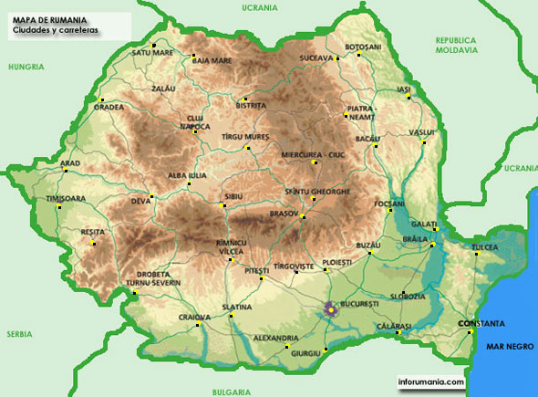
Map 3.1: Arad and Timisoara
Map of Romania: Cities and roads

Source: InfoRumania (2007)

3.1.2 Issues to acknowledge
Ethnography is about “thick descriptions” of a culture, and the researcher’s task is “explicating” its meanings (Geertz, 1973:9). As Hume and Mullock (in Zahle, 2012) argue “the rationale of the [PO] approach is that . . . the researcher can come close to experiencing and understanding the ‘insider’s’ point of view” (2012:55), which is precisely the goal of this study; to understand other’s realities. Nevertheless, it can be argued that my interpretation of others’ realities may be subjective; however, according to Geertz “there is nothing particularly wrong with this, and it is in any case inevitable” (1973:9). The only thing that I can do in these terms is to account my “positionality” and ground my research, he would suggest.
PO “is not less scientific than other research methods” (Jorgensen, 1989:7). The steps that I followed can be considered to guide my approach more systematically, and give validity and rigour to my study. First of all, I integrated in the community to a great extent (Jorgensen, 1989). I do not mean to generalize my results beyond the geographical limits where it was developed. PO is context specific; it is about the quality and not about the quantity of data (Jorgensen, 1989; Chambers, 1983). Furthermore, I will keep the first person “I” as Brow (1996) suggests, in order to remind that this is my perception and not a universal reading of the facts. Along the case study chapter, I recognise my background and how that might have influenced my vision about the setting of my research, maybe considering it more “exotic” than what it might seem to others. Secondly, since the very beginning, I kept a diary where every day I noted what I had seen, learned, my impressions and reflexions (Jorgensen, 1989; Hay, 2000). I verified the information as much as possible, through making the same questions to several people or being more careful observing what I had been told. Subsequently, this information was systematically coded in order to make the best use of it in the final report. Finally, I complemented the PO method with a comprehensive literature review and photographic material. Due to the short period of my fieldwork, triangulation with different methodologies is regarded as an important measure (Jorgensen, 1989; Iacono et al., 2009; Brockmann, 2011).

3.2 Photographic material
The relevance of the visual in the contemporary world is nowadays broadly proclaimed (i.e. Rose, 2011; Bericat, 2011), and this ought not to be neglected by the social sciences. Those should learn to take advantage of the possibilities that the “new” technologies offer in these terms (Bericat, 2011; Roca, 2012), for instance photography. Haddon, Spencer and Boas (in Ortega, 2009), considered the camera as a microscope, whereas Boas and Mead (1942) saw photographic material as part of their fieldwork diary. Jorgensen claims that “several hours of verbal description […] may be reduced to a few minutes of photography” (1989:103). In any case, photography is regarded as an excellent technic and resource to support social observation methods, potentially enriching the analysis to a great extent. “Visual images can be powerful” says Rose (2011:10), because the advantage of photography is that it gives a visual idea of the setting of research and of what/who has been researched. A “footprint”, as several academics on this field call it, which remains in time and space (McQuire, 2013). I believe that images can lead to a better understanding and greater attention to interesting details. Moreover, photographs allow further analysis of fleeting facts.
During my field work, I was especially interested on photographing diverse quotidian activities, as essential reflection of the daily constitution of life; and material assets, in order to give a visual sense of the social and physical context of the region of study. Chambers and Conway (1991), point out the relevance of the household as a livelihood’s unity of analysis. The “tangible assets”, as they denominate to the families’ possessions (water, land, livestock, farm equipment, tools and domestic utensils, cash, textiles, food etc.), are good indicators of issues that might go beyond verbal explanations and undercover hidden realms. Those were important targets during my fieldwork as they “potentially provide rich sources of […] primary, research materials” (Jorgensen, 1989:91) if analysed within what Ortega calls a “sociological eye” (2009) and Rose (2011) says is a “good eye”.
In my research I used photography, however, not as mere supporting illustrations. As recommended by Roca (2012), and because images may not give information “per se”, I properly identified, contextualized and presented each photograph so it (hopefully) brings useful additional information in my study. A correct balance between images and text, as suggested by Ortega (2009) and Bericat (2011), should bring better understanding and rigour to this additional method.
Furthermore, as human-made artefacts, photographs contain a subjectivity that needs to be decoded (Rose, 2011). The message of a photograph is not “innocent” nor the photographer, as Ortega states (2009). It responds to a concrete goal and it is temporally and spatially specific (McQuire, 2013). Seeking to be clearer to the audience of my research, I give as many details as I consider necessary about myself and about each picture, and further explain what I wanted to recall with it. To avoid inaccurate generalisations and sensationalism, I took and show pictures of settings and people with different backgrounds, not only those which may surprise more to me, a Western researcher, or to the Western spectator. Furthermore, I presented the pictures as they were taken with a digital camera, absent of modifications. To control my own subjectivity, it should also be noted that I showed the photographs to the community where I did the fieldwork and I listened to their comments. This encouraged my reflexivity, giving more robustness to my analysis of the images.

3.3 Further ethical considerations
Through the choices I made in this research, and following the advice given in the literature, I have been able to avoid most of the 6 biases that Chambers (1983) considers observing rural development, as it can be seen in the table below:
Table 3.1: Overcoming Chamber’s biases
Chambers biases | My experience
1- It is a trend among researchers to remain in urban cores. In the case they develop research in rural zones, remote places tend to be neglected because of the difficulties accessing them. | I focused and placed my research in a rural area. My informants took me to many different households, avoiding to limit my investigation to those placed in better communicated locations, which often are the less humble.
2- Organisations and well-known areas promote more research, neglecting less popular and more marginalized zones. | I did not go with any organisation and I did not undertake research in already targeted areas. This allowed me to develop independent research and to avoid regions which would probably present biased conditions.
3- Access to the private sphere is not always feasible, which complicates accounting less visible groups such as women or ill people. | I gained the confidence of my informants, which allowed me to get into the private sphere. Nevertheless, I never pushed any situation. I was respectful, and everything I had the chance to experience was due to my natural integration into the community.
4- Seasonality is a factor to account | I went in summer, where labour and social life might be generally more intense. Since I could not avoid the 4th biases, the only thing I can do is being conscious of it and leaving this point clear to the reader.
5- Diplomatic biases: politeness and timidity are sometimes a deterrent. | I was often too polite in order to avoid disruption, especially taking photographs. Nevertheless, as several authors suggest (i.e. Jorgensen, 1989; Rose, 2008), cameras are quite obtrusive; hence its use remained correctly dependent on my familiarity with the people.
6- Personal training and interest may limit the observation. | Despite my background, I tried to be open-minded, not imposing my knowledge and learning more than teaching.
Source: own elaboration
Overall, I have been able to go beyond the frontier of remote rural areas and hidden private spheres. To research non-already “exploited” zones and to learn the community from the grounds in a holistic fashion. Additionally, I have proceed ethically, trying to avoid being intrusive in people’s life. Further considerations are: The raw data that I collected are saved in my personal computer, being me the only person having access to them. I will not reveal specific places, and I will give pseudonyms to my participants. I told them whether they wanted me to send them this report once it was finished and/or the photographs that I took from them. According to their preferences, I will do it once this dissertation is finished. I followed the Ethical guidelines of the University of Edinburgh and the one provided by the American Anthropological Association.

Chapter 4. Comuna from the grounds
One of the first reflexions that I noted on my field diary once arrived in Romania was the following: When one enters in Romania, when one starts to become familiar with the Romanian society; it appears very clear that this is not a modern world understood the purely Western way. The geopolitical borders of the country (with the ex-soviet world), its history (its communist past), and society and their life styles; it all emanates a differentiated tone if compared to the West. Maybe Romania, as a EU NMS, might be in process of Western capitalisation; but up to date, it is not a UK neither a Spain.
During the month that I spent in let’s call it Comuna – this is the entity into which villages are concentrated in order to be administrated in Romania, but here I will refer to it as the small village where I did my fieldwork, – only two people told me something about the CAP. The first of them was the owner of the farm where I was staying; he is a well-educated man who had been living in France for several years. When I asked him if the CAP subventions were actually reaching peoples. He answered that it does reach the big farms, but small family holdings, which are the great majority of the rural population, do not receive anything from it. The second person was one of the workers of the farm (Oigres), and was precisely the one who had spent several years living abroad, in Western Europe. Coincidence or not, he told me that he had a project in mind and that he would seek for European funds. However, other than that he did not know anything else. When I asked him if he was referring to the CAP subventions, I had to explain him what it was, and he suggested whether I could check how funding works, so he could develop his idea.
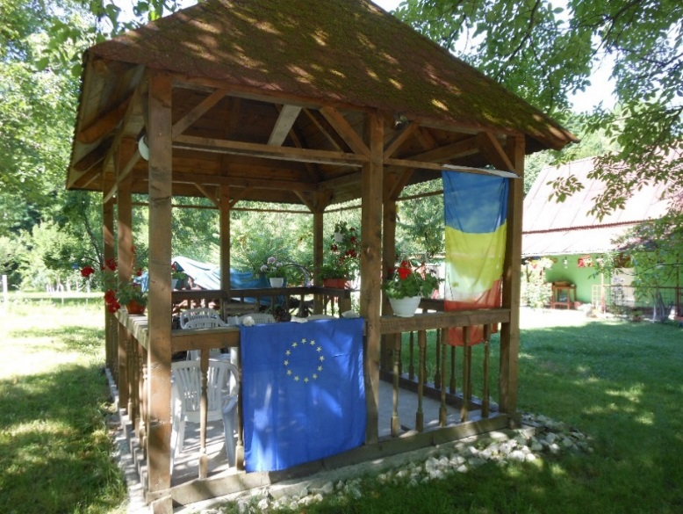
Although the lack of CAP schemes in the area, and the unawareness (or maybe indifference) that I could perceive in relation to this policy during the month that I spent there, the EU still manages to reach the region (P-1). P-2 shows a political poster of the Romanian Democrat Liberal Party pasted to a lamppost in the main road of Comuna. The picture was taken by the time of the European elections – participation in Romania was around the 20%, which is a quite poor figure if compared to other countries – and it urged to vote. Nonetheless, the differences with Western Europe go far beyond the acknowledgment of the CAP, flags, or the percentage of voters in the European elections.
Photograph-1: These European and Romanian flags were permanently (at least during my stay) in this house. The owners were people from the city who used to come during the weekends. Many of the other households used to have a small Romanian flag next to the house number (at the door), but not the European one.

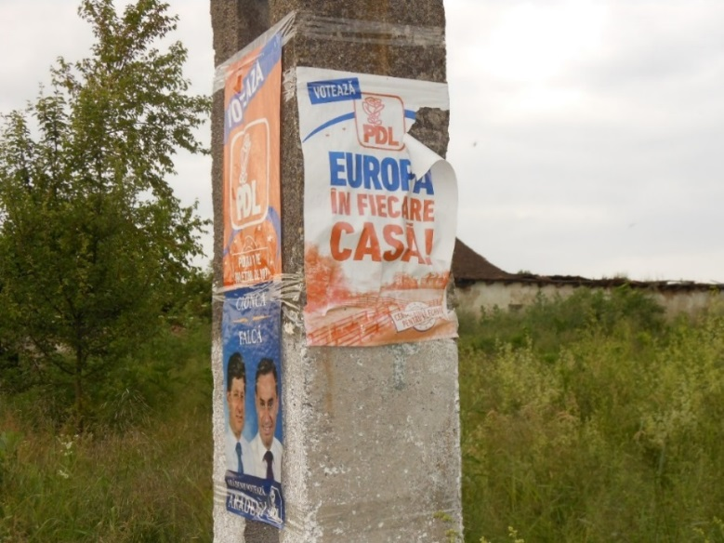
Photograph-2: “Europa în fiecare casă” means “Europe in each house”; to what Oigres interestingly told me “do not believe all they say”. There were several posters and billboards around the area, and some seemed to have been removed (I do not know why this one was broken).

4.1 Where time converges
For a Spanish young woman like me, getting to Comuna was like going back to the past. The houses, the life, the people; everything seemed old, traditional in a way that seems to have been lost in other countries. I noted that Comuna was not a single exception, since I moved around Arad and Timisoara, and my impressions were similar. Let me remark that I am saying so with an admiring tone, rather than suggesting any stigma of primitiveness. Nevertheless, this situation also seemed to entail humble living conditions, when compared to what most city middle-class Westerners might be accustomed to, as I had the chance to discuss with the farm’s owner.
On the other hand, the so-called modernity appears to be gaining its place in this society. In a Romanian train, one can find people dressed with traditional clothes and hats sitting next to people wearing tailored suits and working with their laptops. In many villages, roads are not paved but almost everybody has mobile phones. People live surrounded of and tightly attached to nature (P-3), and still in some villages there are “built artificial” parks (P-4). Here, Volkswagen cars advance horse-drawn carts along the roads (P-5). The locals would not understand my surprise in relation to these contrasts, as they provided me the chance to acknowledge; that is how their life is. Let’s face it, I would also be astonished if an alien would come to my house to take pictures of my kitchen (as I did in Comuna). Nonetheless, Romania is from my outsider’s perspective an in-between world.
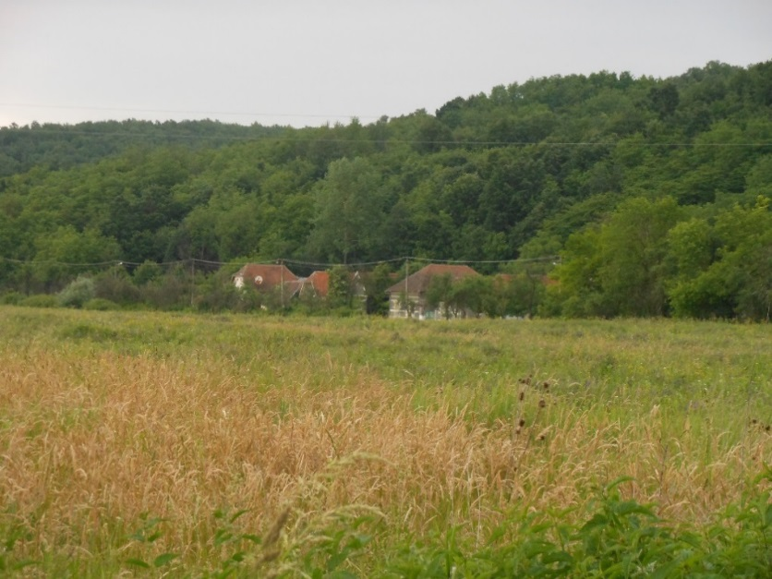

Photograph-3 This is the entrance of Comuna, one of the smallest villages in the area.

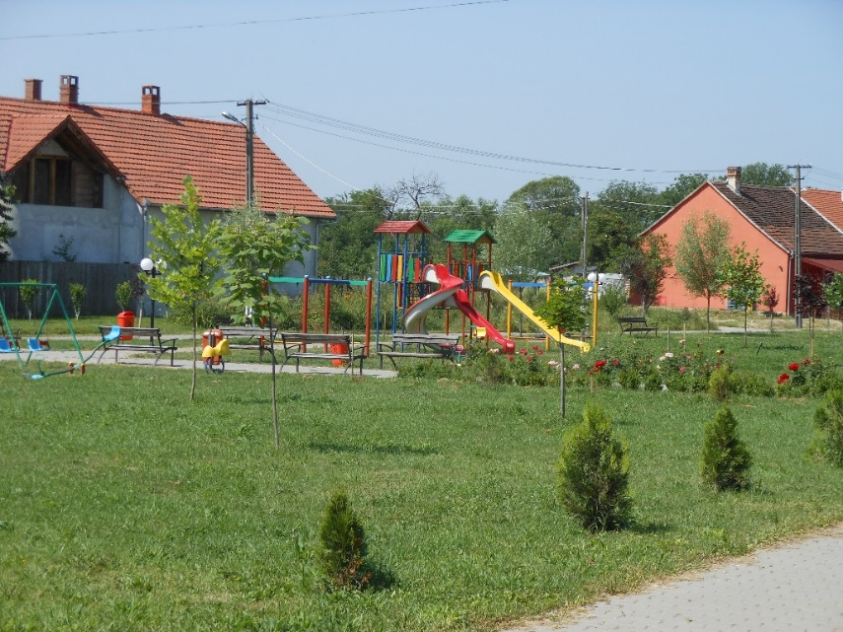

Photograph-4: This park is situated in the main village of the administrative area where I did my fieldwork (not in Comuna). As such, there were more facilities than in the smaller villages and the road was paved. The different atmosphere might be perceived.

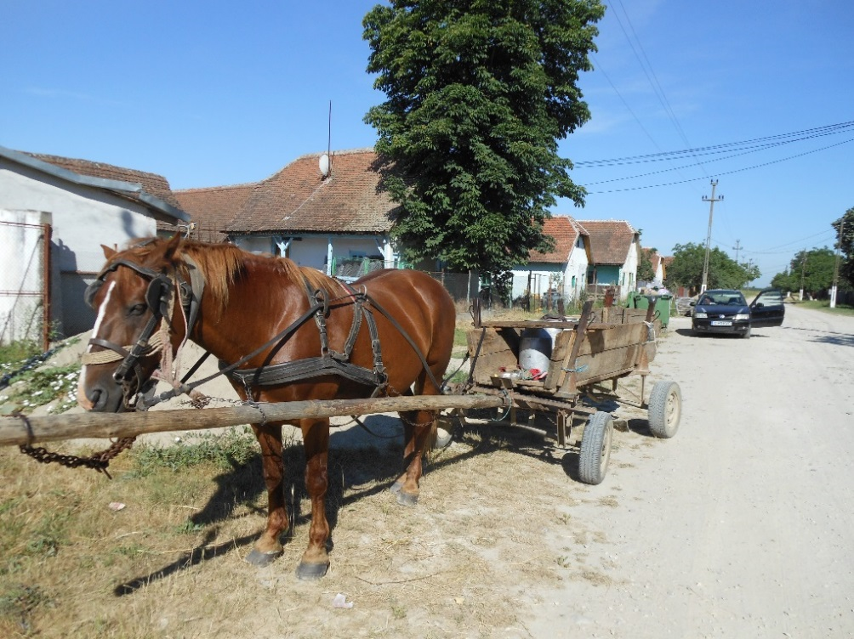
Photograph-5: This photograph was taken in other of the smaller villages. We can appreciate that the road is not paved. This is the cart of the goatherd or the area. He was caring milk cans. The car behind is a second-hand Volkswagen.

The households and its material assets reflect this particular character of the rural Romania. Here, taps, cookeries and toilets are substituted by wells, wood burning stoves and latrines respectively; basic utilities that are present in every single house. – At the beginning of my stay, I was so blind that I kept searching for the toilets in the houses were I was invited because I could not acknowledge that they had latrines outside. My ignorance regarding these kinds of livelihoods reached such and other levels of stupidity. One thing is reading in official reports that only 10% of rural population benefit from sewerage systems. A different one is to experience that pumping water from the household’s well (P-6) and warming it in a pot in wood burning stoves (P-7, 8, 9 and 10) is the regular system to “take a shower” for most of the locals that I met.
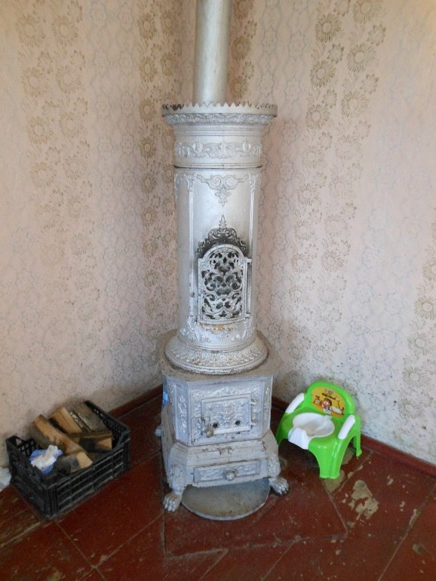
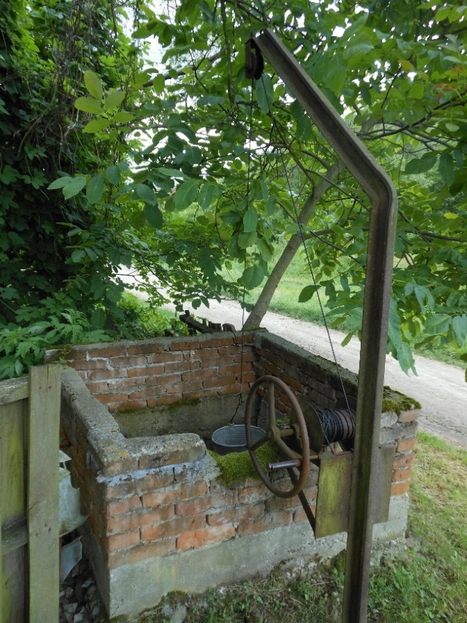
Photograph-6 Photograph-7
This wood stove was placed in the main room of a family’s household. It was used to warm the bedroom and pots of water for different purposes. The latters were placed on top of it.
There were several kinds of wells, inside and outside
the households. Many of them were covered with a
tiny roof.
Photograph-8
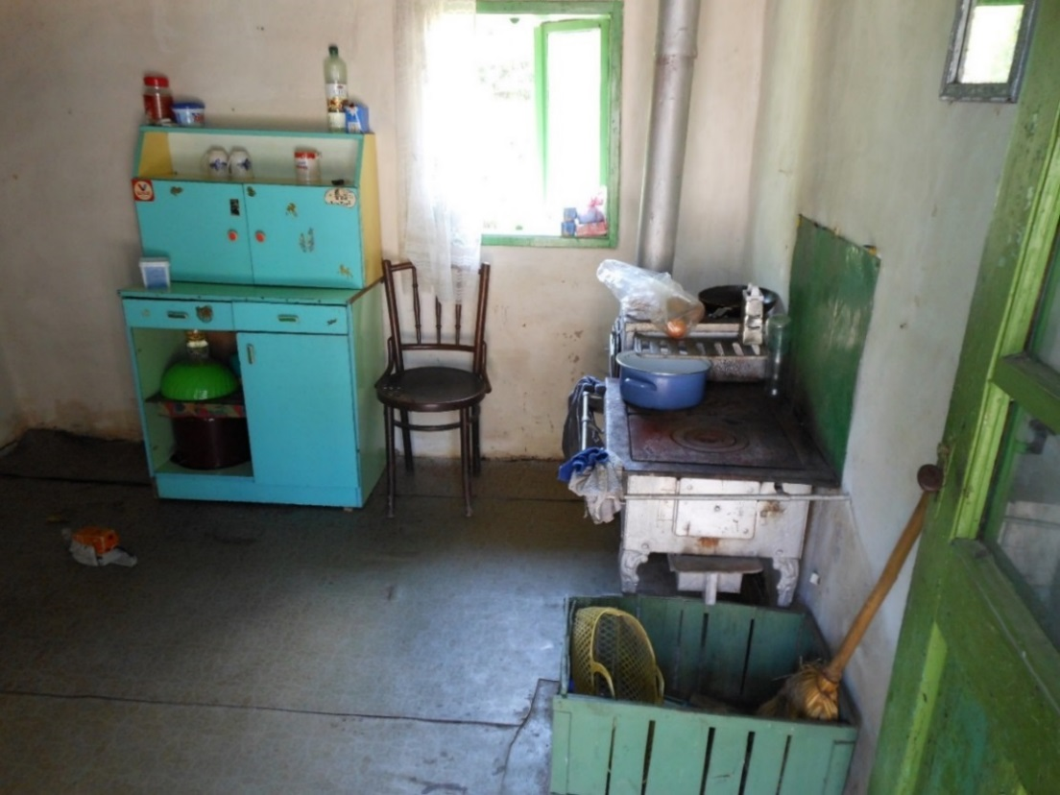
The stove on the right is wood-burning. In this same kitchen (right in the corner of the left) there was also a small gas stove. The family would use both. The kitchen was small, we used to beat us over the head getting inside. All the brooms were as the one appearing on the green box of the left, I did not see any made out of plastic.

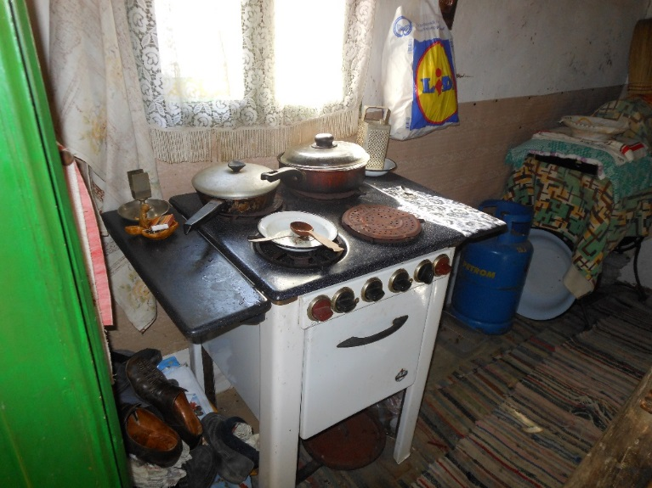
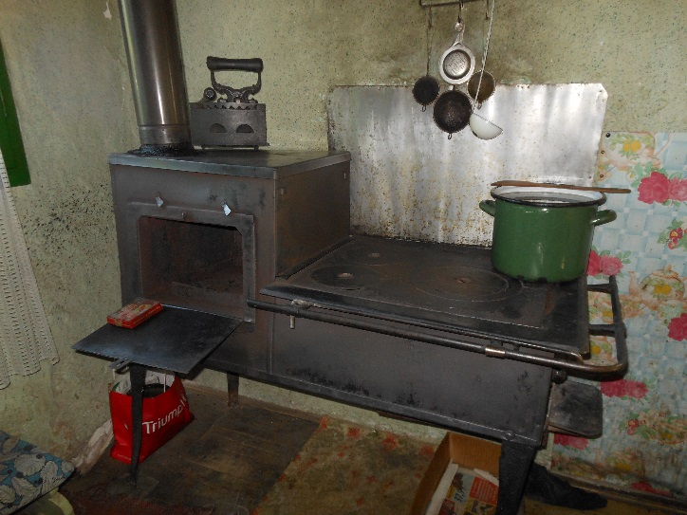
Photograph-9 Photograph-10
These two cookeries were in the same house. The one on the left is a gas stove. We can see that Lidl plastic bags reach Comuna (P-9). In the image of the wood burning stove (P-10), we can also appreciate a traditional iron (on the left top of the stove). These stoves are relatively new compared to others that I saw (one even made out of clay).

The houses and especially the sheds are usually built up in a traditional fashion with natural materials (timber, mug, dung and straws). Commonly, each household has separate buildings – for several family-members, some livestock, and sheds for wood and tools for the garden (P-11) – in an interior yard. All of them had a small orchard (grădină); which is an important component of the household, since it is an important source of food for the family (P-12). The division of the rooms and its respective functions, that is, the separation among kitchen, living room and bedrooms, might also need to be clarified. In some cases, the kitchen is also the sitting room. In others, the living room is bedroom at the same time. Sometimes, the main rooms (cameras) host smaller family nucleuses (young couples with small kids) within the broader family and household. Those spaces are absolutely multifunctional. Xela (one of my peers at the farm) told me once “here bathing, eating, sleeping and everything”. These cameras, which are quite limited in terms of space, include wood stoves, beds and/or sofas, wardrobes, blankets, sometimes certain technological devices (such as old computers and televisions), and other necessary things. As previously stated, certain degree of “modernisation” can be found, but this is usually related to the purchasing power. The lawyer’s house, for instance, had been refurbished and was even served with running water. Nevertheless, it is important to note the bad conditions of many of the houses, which were partly destroyed and untidy.
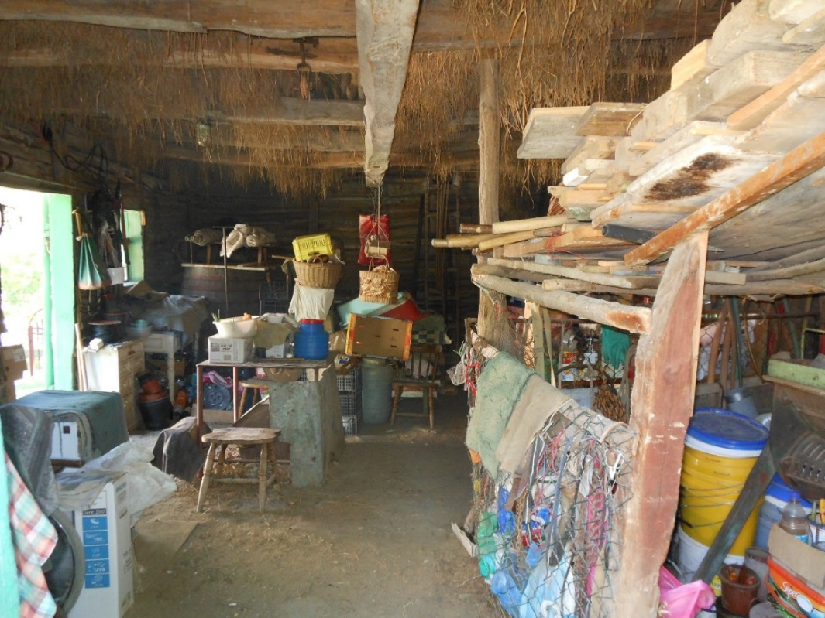
The machinery is another topic. In the farm, we had two old tractors which were always giving problems – luckily, Xela was skilful and very handy in repairing them. – According to Oigres, there was only one more tractor in the area. Walking around, I realised what he meant. Machinery and tractors tend to be placed at the entrance of the households, outside, in the street; apparently in order to reflect the purchasing power of the family (P-13). There were, in fact, a few of them, but these looked really old and broken (P-14). They could not be used to work, and those which could still be used were few for much land. Maybe this is why I saw a man ploughing with horses instead; mechanic and manual tasks converge here on a daily bases. The pictures below show the commented assets.

Photograph-11: This is a household’s shed. In this picture we can appreciate the pebble floor and the roof made of straws, which was very common.

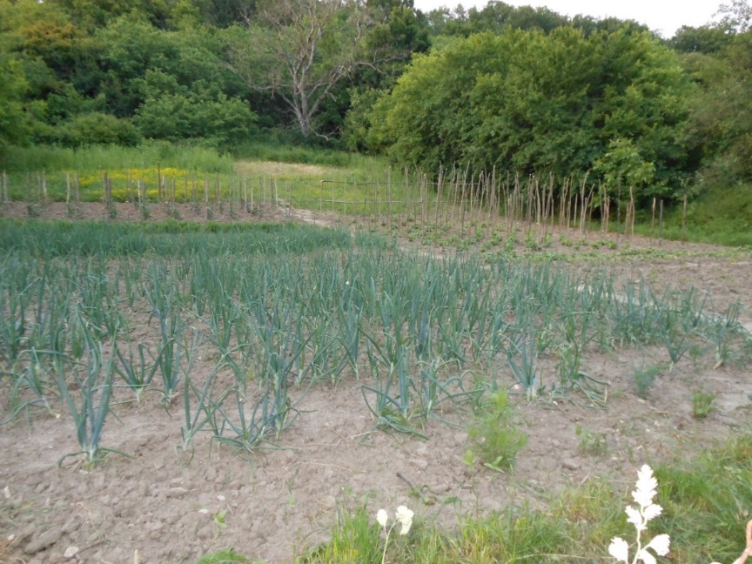
Photograph-12: A small plot in Comuna. Orchards like this one were present in every household.
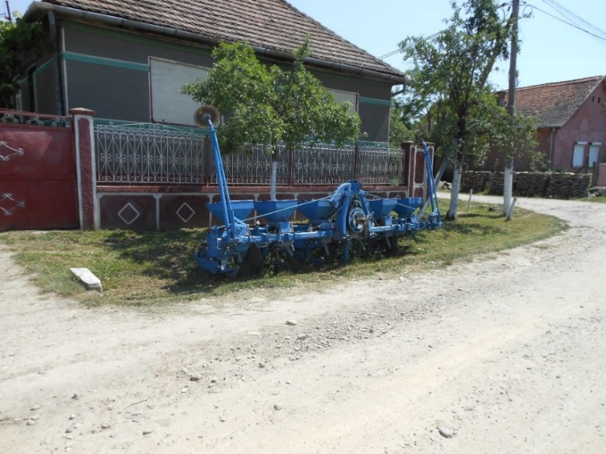
Photograph-13: There were this and older kinds of ploughs all along the streets of the villages (P-13). P-14 is one of the “better-conserved” privately-owned tractors that I saw in the area. Few days after this picture was taken, the tractor’s wheel was repaired.

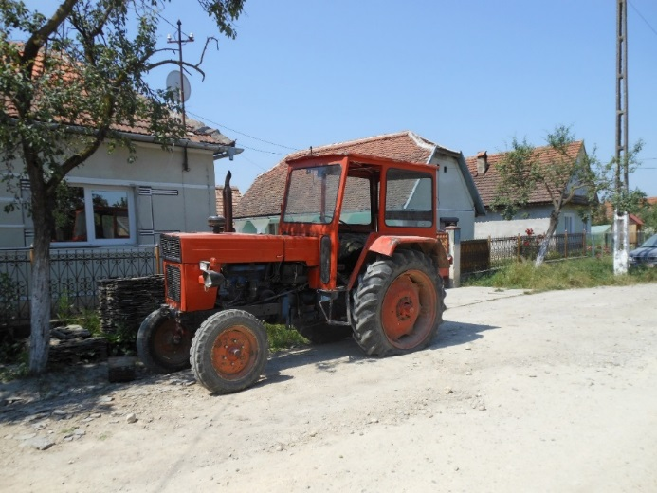
Photograp-14

4.2 Work, social ties… and more work
In terms of labour, differences are not smaller. From my experience in Comuna, I can tell that work is constantly present in the everyday life; there are always things to do. It is not about fixed schedules or physically separated working spaces, nor about being a specialist on a specific field or task. Work appears here in very different formats and requires a great amount of skills. If these peoples had to repair a wheel, they would do it in a matter of minutes; if they had to use the cart, they would tie the horses to it. Nevertheless, these activities are often intrinsically (tacitly) inserted within “leisure” and social interactions.
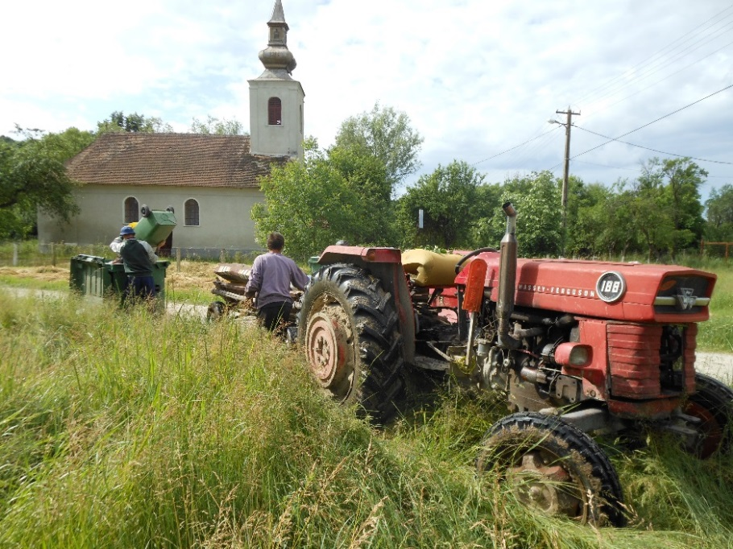
While I was in the farm, we would work on the orchard, clean the barn, or bring drinking water from the village with the tractors (P-15). Women would collect fruit and vegetables, clean (often by hand) and cook. Men would cut wood and grass (both with axes and scythes respectively, and with mechanic tools), carry heavy trunks, and refurbish the household. Pluriactivity here is the norm. I saw several beekeepers around Comuna (P-16), goatherds, and people working in the local factory near Timisoara. The same young men that I saw one day cutting the grass with a scythe, a few days after were charging it in a horse cart, and were driving a van full of stone from the local quarry the week before – where a young couple breaks rock to make their living (P-17, 18). Those activities are complemented with the daily activities of the orchard.

Photograph-15: Bringing down the garbage of the farm to the containers of the village. We used to tie a wooden trailer to the tractor. One would drive it and the rest of us would go sit down on the protection of the wheels. There was not a recycling system in the villages. Everything would go in the same container.
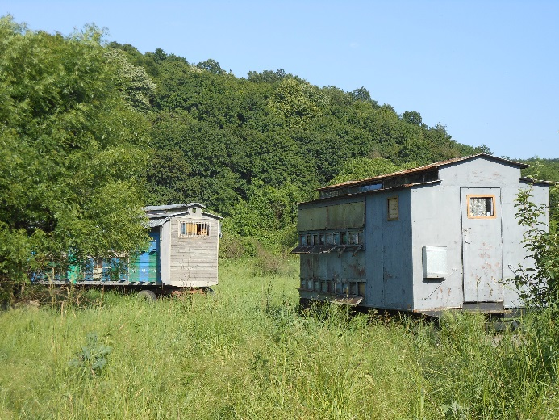
Photograph-16: Honeycombs. There were at least two more from different owners in Comuna.

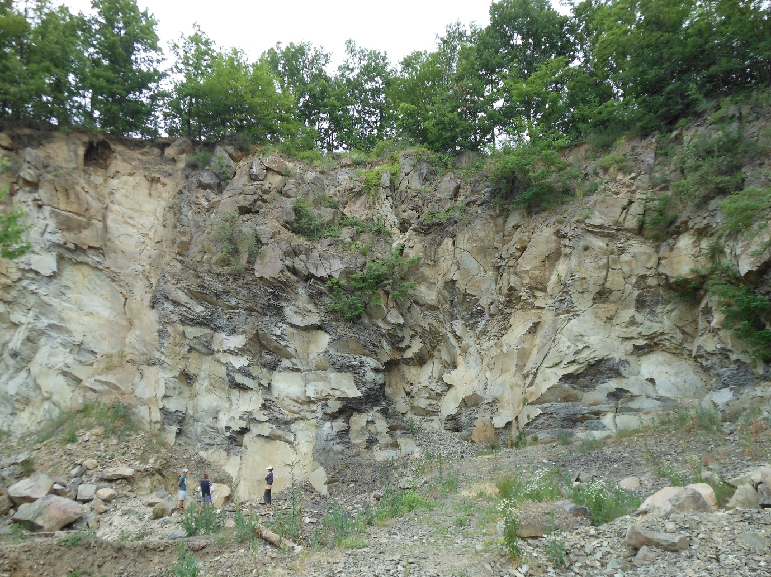
Photograph-17: The local quarry; it was not much bigger than what we can see in the picture. The man on the left and the women on the right are the owners. They live in a small village nearby. They are the ones who break the rock, and they do it by hand, with picks. They pay to some local young males to bring it down to the village (employing acquaintances is very common). The man in the middle was offering them help.
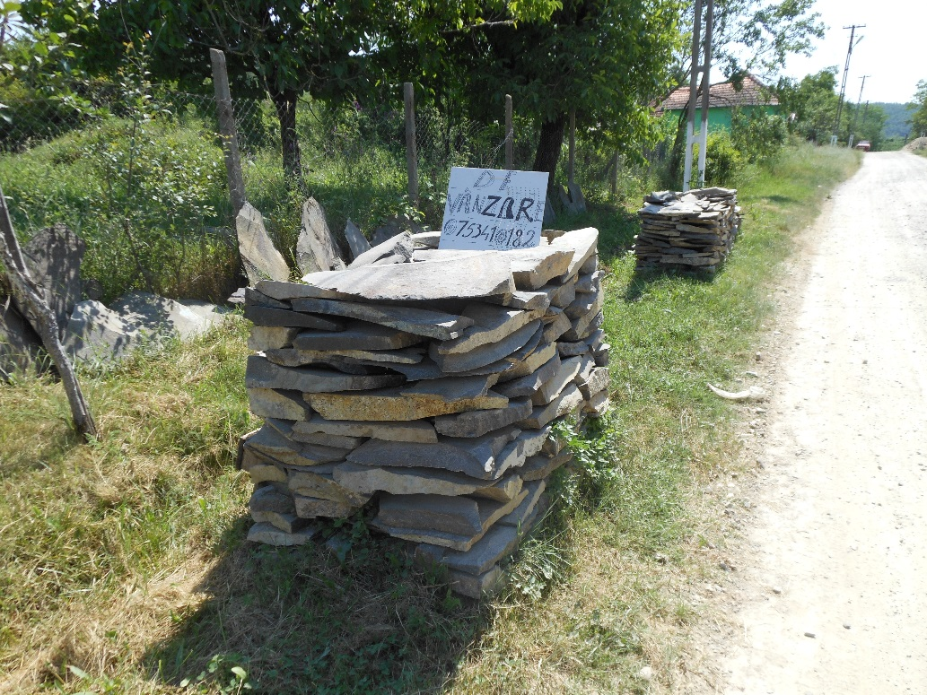

Potograph-18: This is how they pack the extracted rock and put it in the entrance of their house. The sign says “for sale”, and gives a phone number. They extract the rock and sell it themselves.

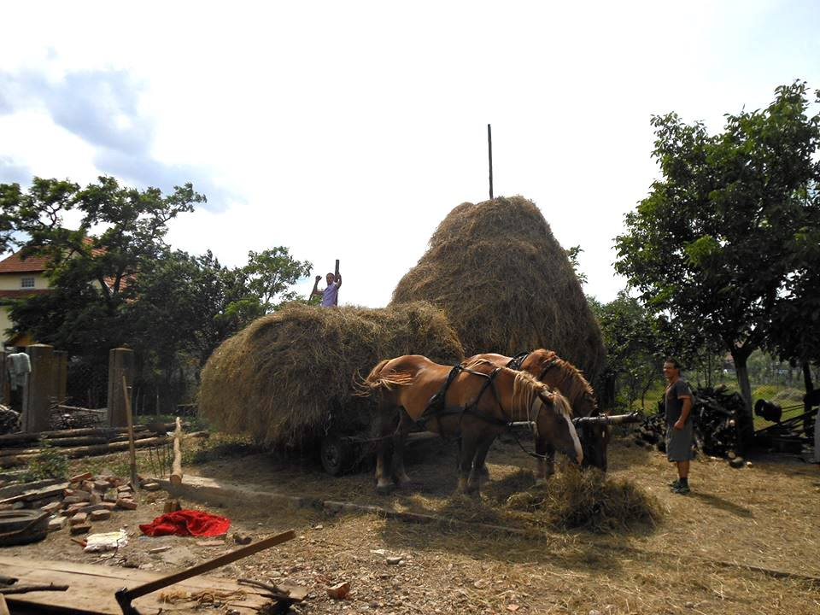
Finishing the working day would just mean going back home and keep on working, fixing your own broken well, for instance. To visit the family meant for Xela and his wife Anadnav, keep working for the whole weekend. As it happened, we (I was invited to join them) had just arrived to the family household (near Timisoara), when one brother of Xela and their brother in law came with a vast cart of hay. My peer, who had recently taken a bath and wore nice clothes for the occasion, started to discharge the hay straightaway (P-19). This was not a punctual fact. That evening we went to Anadnav’s family home and, together with one of her brothers and her father, Xela started to paint a room and kept doing it until 2 am. We, the women, were also busy taking care of their little son, cooking and removing the bones of kilos and kilos of cherries in order to make jam, also until 2 am (P-20).

Photograph-19: Visiting the family on Saturday. This picture was taken inside Xela’s family household, in the backyard. The guy next to the horses is one of his 7 siblings (another one was behind the cart). They discharged the hay in no more than 20 minutes. They are also experts in dealing with the animals.
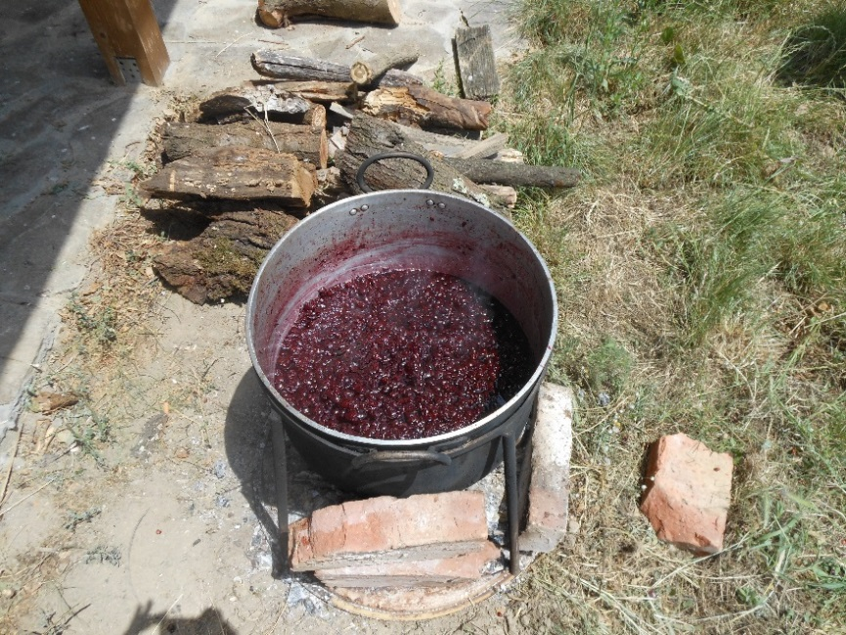
Photograph-20: Pot of cherries to make jam. They prepare compot in order to preserve fruit for the winter time. The farm owners told me that some traditions like this one still remain even in the cities. The process of making it was also a way of socializing for the women; I did so in three different households.

Sunday is really meant to be the day off, people used to say “on Sunday nobody works”. But this is quite relative. Walking to the Orthodox Church on a Sunday at 8 in the morning, the goatherd took me on his cart; he was already distributing milk around Comuna. Another Sunday, Xela went to the cemetery with some of his brothers. This fact was not totally exempt of work, since it meant weeding the graves of different relatives. Some way or another, you end up working almost the whole day; and everybody contributes. People were used to work since they were very young – Oigres dropped school at 12, Xela at 8 and Anadnav at 10. Although their younger brothers (around 15) were still studying, they would also work. I could say that they were “productive” for most of the time. Xela and Anadnav made several times comments such as “Maria, always working”; however, not in a moaning tone.
From what I observed, this is also a way of socializing, and it is absolutely naturalized. “Leisure” and working go hand in hand, and both entail exchanges in many different forms. Visiting relatives or the neighbour is very common (P-21). Almost in every house we would visit, people were undertaking different tasks and we would lend a hand. In “exchange” we were always offered food, flowers or any other kind of “reward”. To help, give and receive is often implicit. People would lend you their hose and you would bring them back Țuică to share (a traditional homemade liquor), or help to pick peas or repairing together an old motorbike. This sort of reciprocity is part of people’s leisure. Although vicinity is not exempt of clashes, as I could observe through the realm of property limits in relation to wood felling and illegal hunting (and other coexistence issues); social relations seemed very tight among the locals. One day, I went to the village and, by the time I came back to the farm, I had been invited to three different meals in three different houses; and this without even being part of the community.
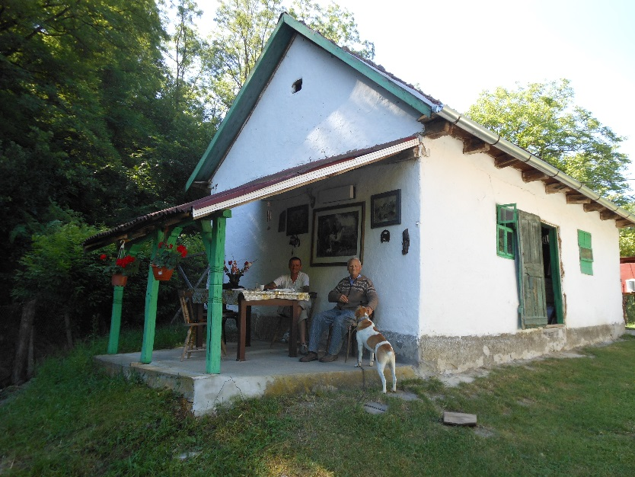
Photograph-21: Visiting the neighbour meant nice company, food and beverage; and cutting the grass. A different day, this 84-years-old neighbour came to visit us to the farm and showed Oigres (the farm worker with the lowest agricultural background) his own technique to plant the tomatoes, since he was not achieving it properly (it was already too hot to plant). They succeeded.

4.3 A thriving community
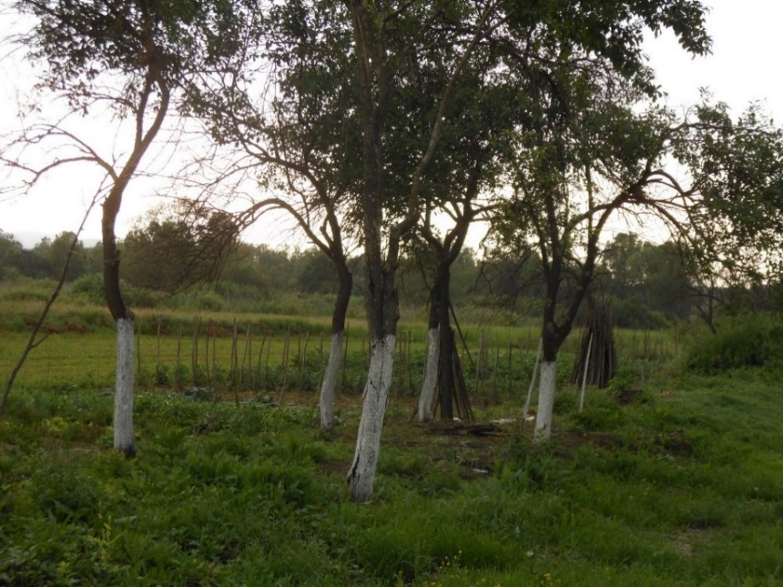
Different contexts require different ways of living. Pluriactivity requires multifaceted knowledge, but a knowledge about one’s world. In terms of agriculture for instance, in Comuna, I would say that everybody practices horticulture. Since chemicals are expensive (as I was told), small farmers do not use them. Instead, they would commonly paint tree trunks with Var (a natural dust extracted from chalk) in order to avoid insects in the fruit (P-22), and remove the weeds by hand. Peoples were often hard workers; all of my peers were much more efficient than me indeed. Furthermore, their knowledge about plants and fruits was remarkable, making good use of their orchard and the animals they breed. I would say that they are quite autarkic – once, a woman told me that her family did not have any money for about 5 months, not even to buy bread, and they still got ahead. These people are great consumers of nature, they are not only farmers, but also great collectors. Twice I have seen them stopping the car in the middle of the road and climbing to the trees because they had recognized different fruits. They make juice from a special kind of flower (Sok), tea from wild plants, and they know how to trace animals in the forest. This also entails being relatively dependent on the environment, climate and natural rhythms; not in vain “month” in Romanian is called “moon” (lună). Nonetheless, the locals have their own strategies. Romanian summers can be relatively dry for instance; in fact, water shortages became a problem during my stay in the farm. If it does not rain in a few days, you cannot keep watering the orchard and you might lose what you had. Nevertheless, these people has a technique to collect the rain water from the roofs of their houses (P-23).
Photograph-22: Tree trunks painted with Var could be found everywere. If we pay attention, we can also see the straight wooden sticks supported on the trees and stucked in the ground. Those are for the tomato plants and can also be found in every household.
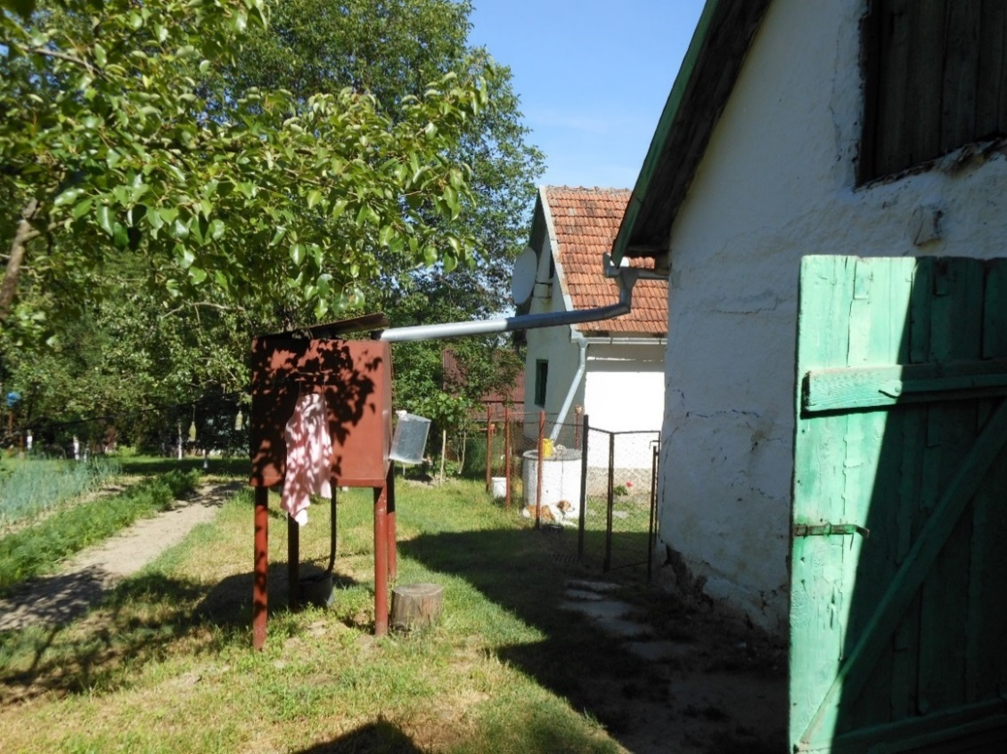

Photograph-23: Rain water collection. In the closest house, the gutter goes to a water tank that is next to the orchard. The aim is to make the watering easy. In the farthest house, if we pay attention, we can see how the gutter goes to the well.

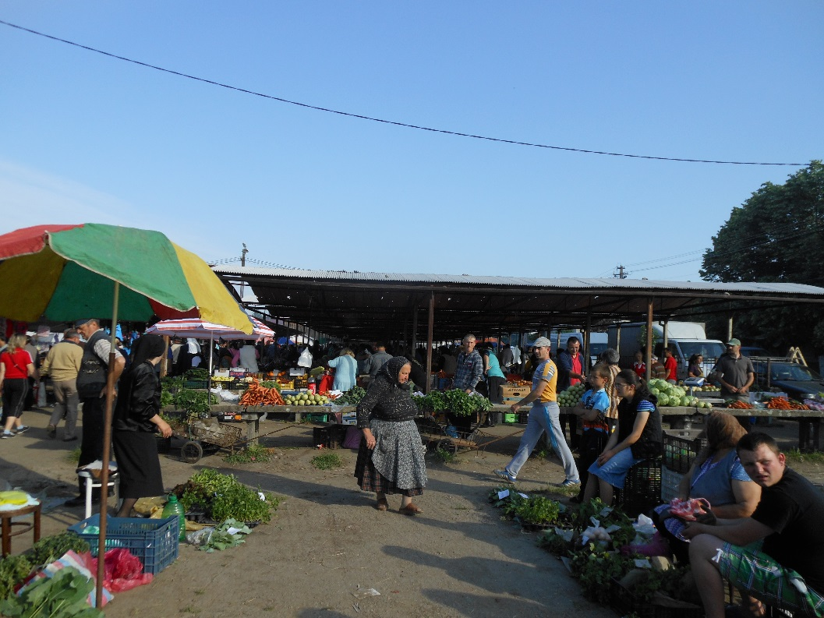
In terms of consumption, I never saw a single big chain in the surroundings. However, local markets and shops (magazin) are the norm, and they are enough to support their relative autarky. On Saturdays, we used to go to the biggest local market, which opens at 5 am and closes at 2 pm (P-24). Waking up early was a common requisite, even on Sundays. Hundreds of people arrived there by foot, car, bus, cart or bicycle. There you could find hats, bleach and socks (P-25), second-hand motorbikes (P-26), handmade gardening tools (P-27), locally produced food and seedlings (P-28), and livestock (P-29, 30). – I saw people bringing piglets in the car boot. From what I observed during my fieldwork, livestock conditions are not always as the ones that the CAP would encourage. Nevertheless, this did not seem to be a problem. Everybody would take their newly acquired hens (găină) in boxes or would hand them from the legs, after a more or less friendly discussion with the seller. –There were also “fast-food” stalls, but those are small businesses rather than big chains. Prices were striking to me. A coffee 1 leu (0’25 €), a hot dog 2 lei (0’50 €), a burger 4’50 lei (slightly more than 1 €), and a kilogram of tomatoes around 4’99 lei (not even 1’25 €). In addition, there were other smaller markets in the area on Mondays and Tuesdays. I asked about the licences and apparently anybody can buy one (those are relatively cheap) and go selling to the different markets – nevertheless, I saw stalls that seemed not very “legal”.

Photograph-24: This picture was taken in the biggest local market on my first Saturday. We can see the detail of the woman wearing traditional clothes (also the one in black on the left). It was very common among elder women.

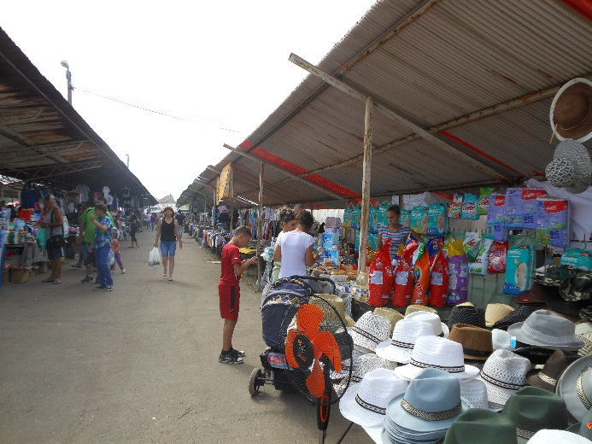
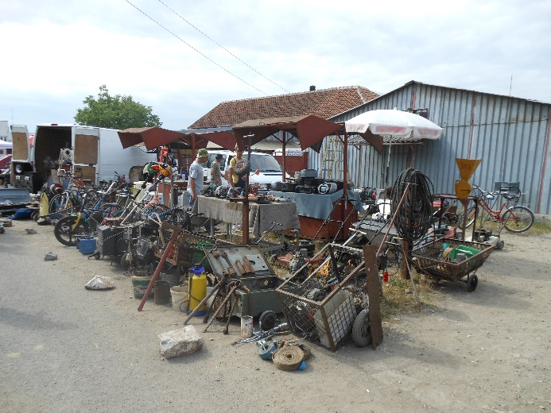
Photograph-25 Photograph-26
From hats and bleach to second-hand tools. Everything could be found. The following pictures are just a small example.
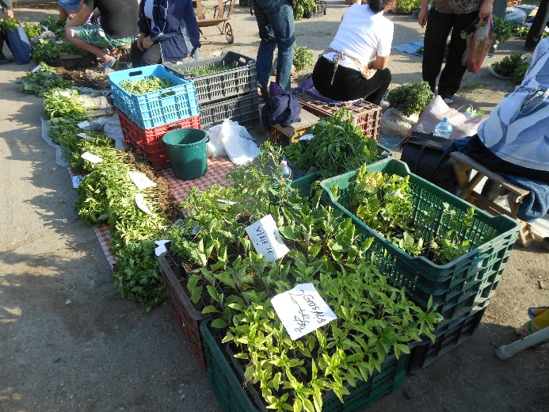
Photograph-27 Photograph-28
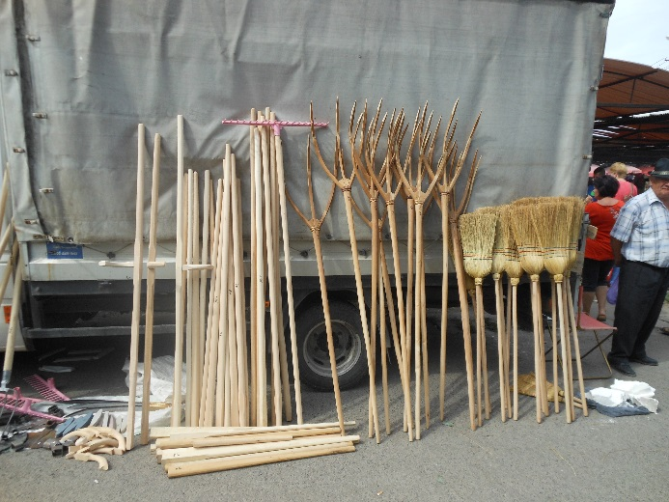
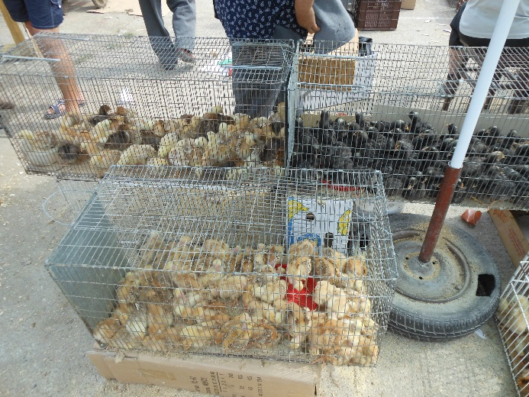
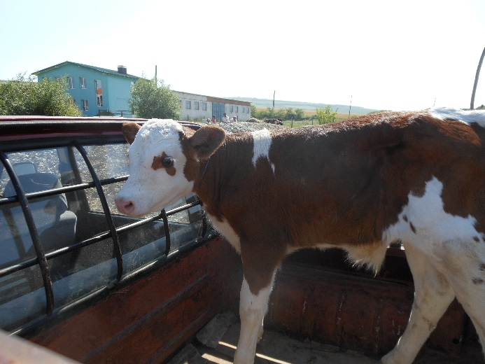
Photograph-29 Photograph-30

On a non-market day, people would go to the local shops. Those included grocery stores, second-hand shops (P-31), ironmonger, and the goatherds’ houses. Along the roads it was typical to see small wine cellars (cramas) and people selling Țuică and their own surpluses. A group of old woman used to vend their products regularly in the street in one of the bigger villages (P-32). They would sell their own vegetables, milk, eggs and cheese; in this regard one goatherd showed me the traditional process used to make cheese in his own hut. Other than that, in the local shops there were also imported products from big companies such as Coca Cola and Nescafe.
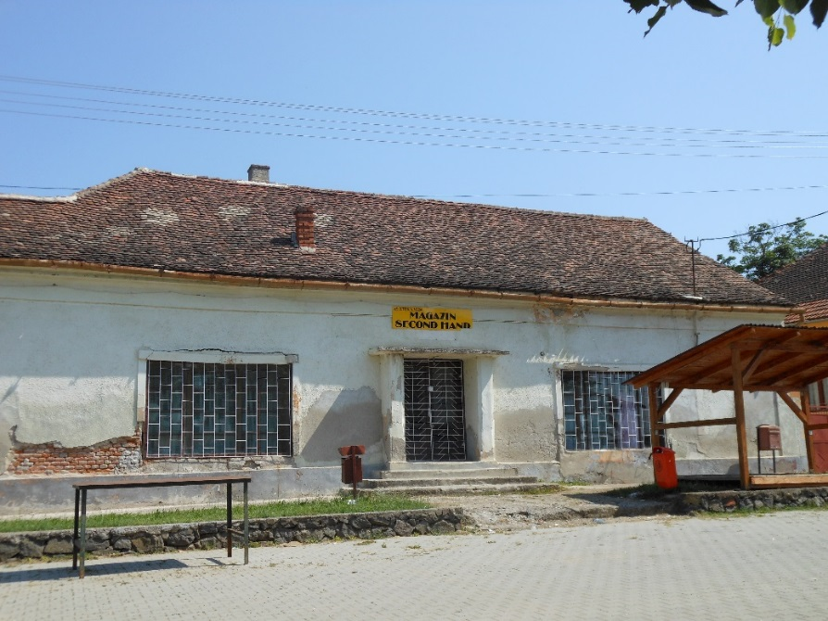
Photograph-31: This is an example of the many second-hand shops that could be found in the area. Interestingly, the sign (in yellow) is half in English and half in Romanian: “MAGAZIN SECOND HAND”. The wooden structure on the right ant the metallic one on the left are the fixed stall-structures that remain form week to week for the market.

Photograph-32: These women used to be in one of the biggest villages selling their vegetables in the street. Again, we can see their traditional dresses.

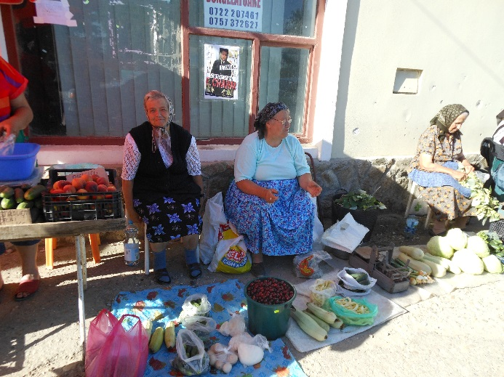
Frequently, rural regions are seen as lacking basic public infrastructure and services. When I asked about the medical centre in the area, I was told that the doctor used to come to a nearby village every Tuesday; which might be seen as a deficiency. Furthermore, even though this is probably a more Western concern than a real issue for the locals, I did miss a recycling system. It might surprise, but when I saw that peoples would burn plastic inside their houses for firing and outside to get rid of it, I could not avoid thinking about this.
Life in general seemed humble to me, but little by little I stopped getting surprised and started to realise that these peoples know and have in the area everything they might need. A part from the previously commented local trade; there are churches, bars, (improvised) football courts and small petrol stations. And in the bigger villages schools, pharmacy, police station and restaurants. There used to be people around, it is an alive area. In terms of social events, I was lucky enough to see a couple of celebrations. A wedding passing in front of Xela’s family house and two local balls (both the same Sunday, in different villages nearby Comuna), where children and young people wore traditional dresses. That Sunday I also saw a football match in one of the bigger villages. Yes, I meet a lot of individuals who had migrated, but somehow, they seemed to come back, and do not especially miss what they left behind. After this experience, I really wonder whether these peoples might be interested in any European programme for rural development, but this is what we will discuss in the following chapter.

Chapter 5. Discussion
I was blind trying to find actual toilets in Comuna; I was a Western on the field, and I acknowledged it then. So I have been reporting my data “visual projections are highly selected stereotypes” (Beilin, 2005:57). My mental schemes are there, and the only thing I can do is “to be more reflexive of the modes of knowing that are intensified because of our particular location” (Mani in Escobar 2012:224) and not trying to claim them as a universally valid reality.
Chapter 4 intends to highlight that Romania is a “hybrid” society (in terms of Escobar, 2012). Escobar’s notion brings us the chance to ascertain that there are, in fact, different subjectivities within the global order, and they need to be recognised (see also Sylvester, 1993). Those, although not necessarily fully modernised, are touched by the hand of development to some degree, and in constant negotiation with this fact, in different ways. We have seen that several traditional and modern synergies converge in Romania. Its peripheral character should not be neglected under the premise that it is actually a European country, because this remains more a project than a founded reality. The periphery of the periphery (and by this I mean the rural areas of Eastern Europe) appears barely comparable to the West. Therefore, recalling to the metaphor of “blindness”, the EC seems to be more than voluntarily blind trying to implement the CAP in Romania as THE measure.

5.1 Diversification and “mutifunctionality”
The global failures of the last decades seem to start somehow being recognised (Wallerstein, 1993) – being optimistic. Agricultural intensification, for instance, is one of the highlighted mistakes, and sustainability is regarded as a cornerstone for the future. In this line and as it is (partly) sustained by the CAP, the diversification of agrarian activities and the recognition of the countryside’s multifunctionality are claimed to be beneficial for the environment, the consumers and the producers themselves. Conversely, “all that glitters is not gold”; Peet and Watts (1993) suggest that sustainability might also be working as a hegemonic linear strategy, as we are about to see.
Chambers (1983) reminds us that rural livelihoods are based on a plurality of different strategies, and so it was appreciable in Comuna. Diversification, as it could be glimpsed in Chapter 4, is nothing new in the countryside. Pluriactivity, or plural economies (in terms of Escobar, 2012) and the subsequent diverse knowledge that those require, are exercised on daily bases in rural areas. People would cultivate the orchard, tow 4X4 with tractors, work on the local factory and collect parsley (patrungel) while cutting the grass. Peoples’ living strategies are diversified as the day-a-day requires; they diversify according to what they need and they have (that is, their knowledge and capabilities) and not because it is somehow externally imposed. To diversify with tourism, example that the CAP supports, however, does not seem that accurate. – It is important to acknowledge that there are other types of diversification, however, it is not possible to talk about all of them. Local industry for instance, seemed slightly more integrated near Timisoara, although Macken-Walsh (2011) is critical about how this sector is regarded by farmers. In Arad, diversification through clean energy generation is glimpsed in the article by Zagoni, Mănescu and Mateoc-Sîrb (2012).
Iorio and Corsale (2009) consider rural tourism a great chance to allow villagers to remain in their place of origin, and one that does not disturbs peoples’ lives in excess. However, it is often outsiders coming to the rural areas the ones that have the interest, capital and knowledge (hence, better access to the CAP funds) to develop such activities (Komppula, 2013). From what I observed, the only person who did developed a touristic activity in Comuna was precisely the lawyer, urban inhabitant, wealthier and well-educated; which partly corroborates Komppula’s argument – although he was not using CAP funds. Nevertheless, it is also claimed that likewise, this brings activity to the area, and indirect profit to other villagers (Iorio and Corsale, 2009; Komppula, 2013). My perception after the fieldwork is different. With the family and household organisation that these peoples have, it is unlikely that they would host visitors; it would be necessary to change their structures to do so. Concurrently, the humility of some of the houses and zones might not result attractive to tourists. Moreover, farmers do not usually want or have the skills to undertake this “odd” endeavours (Hubbard and Gorton, 2010; Macken-Walsh, 2011), diversification from farming activities might leave them in a lost and marginalised position (Osti, 2000; Macken-Walsh, 2011). In addition, tourism simply does not have the strength to allocate 6 million Romanian farmers. Those alternatives are not a generally applicable solution to farmers for the development of rural areas (at least in Comuna), but a vague substitutive of the quintessential agriculture. However, due to its characteristics, in Romania there cannot be rural development without agricultural activity (Otiman et al., 2010) (which is indeed “naturally” diverse, as we have seen). Therefore, promoting an externally conceived diversification, which furthermore tends to be addressed to satisfy outsiders’ curiosity leaving the countryside as a place for non-locals consumption, does not seem like an accurate measure here.
Multifunctionality is also an issue. As we have seen in the previous chapter, the locals have their own strategies in terms of consumption of nature; which directly impacts on the environment. Practices such as the rain water collection, and not using chemicals can be perceived as positive. However, burning plastic is known to have negative repercussions. Again, those choices are brought by the context, knowledge and possibilities. Should the new CAP reform require 7% of the agricultural areas to be afforested (Alexandri, 2013) for example, peoples’ access to these new green payments would be denied; simply because peasants might not be able to afford losing 7% of their already small but essential orchard – although a mix between vegetables and fruit trees was not uncommon. This is not to reject environmentally friendly actions, but to remark that sustainability, understood and promoted under Western parameters and regulations, may not be achievable nor beneficial for these peoples. As Hall et al., claim, sustainability – in this case the compliance of the agri-environmental measures – might be adding “pressure […] on rural livelihoods” (2011:200). The Government of Romania highlights varied “processes of degradation” in the country (2005:173); however, from what I observed, the small farmer is not precisely the one to blame. I did experience the amount of water and fuel savings per household when you do not have running water or you cut the wood by hand respectively. Nonetheless, there is a need to legitimate (Hall et al., 2011) the CAP implementation. However, there is also a need to interrogate. Is it actually “Western sustainability” a locals´ matter or preoccupation? How will these impositions actually affect them? And as Buttel (n.d) asks, will those who have been environmentally friendly previously to the green payments be recompensed? I personally do not visualize any of the people that I met in Comuna receiving money for using Var instead of chemicals for the trees; it is just the way they “know-how” and it sometimes happens to be environmentally friendly.

5.2 “Relocalisation” and social ties
The “relocalisation” or “reterriotorialisation” of food production is also promoted under Pillar II, and encourages local production initiatives in order to defend localism and empower the small farmers (Watts et al., 2005; EC, 2012b). It is argued that it will relink humans and nature at the same time as promote the endogenous capacity and development of small rural communities (Watts et al., 2005; Nourish Scotland, 2013). Ideas of AFN, come (timidly) to the forefront and seek to overcome the traditionally intensive, distant and corporatists Food Supply Chains (FSC) (Watts et al., 2005). The formers are understood through the lens of post-productivism by Watts et al. (2005). Conversely, I believe that, whether this is a more ecological (not intensified) form of cultivating, we are still talking about food production; which from my point of view does not have nothing negative per se. These “alternative” strategies are based on the labelling of Organic and Protected Designation of Origin (PDO) products, farmer’s market, farm shops and direct sale (Watts et al., 2005). Nevertheless, these conceptions are not exempt of critique.
Among AFN, Organic products require a label that needs to be paid, and not everybody can afford. Only 1% of Romanian products are sold as such, and 98% are directed to international export; nevertheless, 70% of the Romanian total production could be labelled (Vişan and Căpraru, 2012). In Comuna, the small-scale production that I observed was chemical-free and non-processed. It could perfectly be considered Organic, however, it was not branded. One of the reasons is that exporting products have to “conform to the strict food safety standards of the European Union” (Thorpe, 2007; see also Barjolle et al., 2013). In terms of animal welfare, Juler (2014) comments the restrictions in the amount of sheep that are allowed to be flocked in transhumance. My examples of the piglets transported in car boots and the goatherd’s process for making the cheese highlight that local procedures are adapted to the local’s capabilities. Otherwise, as Thorpe (2007) claims “the new law will speed up the end of a way of life already in decline”. In addition, access to Pillar II funds for these kind of projects is not clear, as Juler (2014) suggests, – and I can confirm after months trying to understand the CAP – not even the CAP measures are. On the other hand, PDO products cannot be produced anywhere; therefore, their economic support does not necessarily reach the Less Favoured Areas (LFA); not actually reducing local vulnerability (Watts et al., 2005). Furthermore, the CAP was proud to state that its focus turned from the producer to the consumer (EC, 2012b). Eventually, the commented kind of production responds more to Western ideals such as relinking nature and society, and the new demands on healthy and quality food (see Nourish Scotland, 2013). – As I could perceive with my experience in Comuna, those who were concerned about returning to nature, and interested on organic and quality food where precisely those who had had more contact with the Western world. Common peoples would directly cultivate and consume their products (and buy others’) without considerations of this kind. – Therefore, responding to external consumption, these products turn into value-added goods (which is actually specified as a goal in the EC’s report, 2013:6), returning to market economies and rural development dependent on exogenous forces. Sylvester would consider these trade structures as a form of colonisation (1993); far from benefiting locals when promoted by and for external consumers and according to their external normative. Macken-Walsh (2011) reports that farmers (especially men) are not usually interested in these “alternatives”, which force them to adapt with each CAP reform and do not benefit them economically.
About local trade, Watts et al., (2005) claim that farmer markets, local shops and direct sales entail less vertical relationships (not responding to external consumers), therefore being perhaps a better solution. Although, they claim, some sellers may compete with others and even reach the traditional FSCs if their economic returns considerably increase. In these terms, Burn and Purcell’s caveat about what they call “the local trap”, may be understood (2006). They claim that localised food production is not inherently positive, in a sense that it might be controlled by certain elites, hence, not benefiting humble peasants, again.
In Comuna, however, it would not be accurate to talk about “relocalisation” of food production or re-enhancing human-nature relationships. Those are already there, they are peoples’ current reality. If we remember, locals go to the principal market on Saturdays, to the local shop during the week and sometimes they stop their cars to buy to the “always-there” old women or to go to the goatherd’s hub to directly buy him cheese – a cheese whose production certainly does not accomplish with the CAP normative, and is delicious. Here it would be about avoid pressuring peoples with market competitiveness or rigid and complex (sustainable) regulations, in order to let them continue as they are.
The issue of local trade allows us to approach the topic of social relationships (and competitiveness among residents). Watts et al., (2005) consider that the direct horizontal relations that it entails might promote a better communitarian atmosphere; trust and reliance, they state, are necessary in these kind of exchanges. On the other hand, Hall et al., (2011) recall that social relations within rural communities have often been romanticized, in a sense that they seem to appear characteristically close and supportive among their members. They criticize Geertz’s considerations about “shared poverty”, arguing that the market also intrudes kin’s and neighbours’ relationships disrupting valued social ties, because competitiveness among them appears. Hierarchical and even exploitative relationships (although not new) originate between those who own the resources and those who do not, and land access might be constrained (Hall et al., 2011). Conversely, Salazar’s study about rural Irish societies reflects all the contrary (1996). He considers rural social and economic ties differentiated to the global capitalistic relationships – although, he recognises, those remain within capitalist structures – to such an extent that he titles his book “A sentimental economy”. According to Salazar (1996), despite that modernisation is reaching and transforming the rural world, kinship and neighbourhood still entail much closer interactions there. The sharing of the space and the day-a-day contact usually transforms working contracts into cooperation, and economic payments into exchanges of any kind, including symbolic amounts of money and further help (Salazar, 1996), and; as commented on Chapter 4, everybody contributes. Cleaning the car in the local petrol station on Sunday was free for Xela because at the same time, he helped cleaning others’ cars. On Saturdays, the goatherd did not usually let Oigres to pay him; “in exchange” for the cheese, he used to bring him alcohol. My experience in Comuna and near Timisoara was so far closer to that of Salazar (and to that of Juler, 2014), as reflected previously. Even when there were property-limit problems, those seemed to be clarified. Furthermore, beyond being competitive, sellers where helpful with each other; there was no problem about installing stalls next to permanent shops, for example. Capitalist accumulation does not seem to rule within this society, not yet at least.

5.3 Politics and interests
The institutional structure, both national and international, is eventually the one pulling the strings; and so it does in terms of the CAP. In his book “Romania after Ceaușescu”, Gallagher (2005) constantly claims that, although Western Europe has pulled forward several efforts in order “to promote aspects of West European governance” (2005:233), Ceaușescu’s communist dictatorships has still its influence in Romania. Ex-communist leaders still occupy institutional positions, influencing a “flawed and incomplete transition” to neo-liberalism (2005:7), as I reflected in the previous chapters. In terms of agriculture and rural development, “Romanian communists were able to impose the power of the state down to village level, no other government ever succeed in doing this” (Gallagher, 2005:7). Golea (1988) reminds us how repressive and forced was the collectivisation of the land during communism. These are important issues to acknowledge, because the past intrinsically influences the present; as Halle et al., claim, there is a need to “situate dilemmas” (2011:199). The effects of communism in the agrarian domain (i.e. fragmentation after land devolution, pollution, the conditions of irrigation channels and infrastructures), the lack of democratic experience and, according to Gallagher (2005), the scepticism on the political institutions – and cooperatives. It is highlighted by Macken-Walsh and Curtin (2013) that village cooperatives are often rejected by locals, associated with communism – are accused of being hampering rural development, and the integration of the CAP (Barjolle et al., 2013). In Comuna, there were no CAP programmes, and people in fact made comments about corruption.
Gallagher (2005) claims that Romania has still to adapt to Western Europe’s schemes. Nevertheless, modernity is alongside being embraced, as we have seen, and hence so it is the CAP. Statements such as the one made by Mungiu-Pippidi (in Juler, 2014), reflect an institutional interest hurrying the modernisation of the rural world, in its most crude form.
“Seven million peasants, who barely reach subsistence levels, have no idea of the difference between the political right and left, and buy on average a single toothbrush in a lifetime, pose a development problem not just for Romania, but for the European Union [EU] in general. It is hard to believe that by the twenty-first century the peasant problem in Romania has […] remained unsolved.”
In this line, the BBC’s interview to Marian Avram (Thorpe, 2007) states the following:
"I'm not against traditional producers […] but I am against extremist traditionalism. For a moment he makes it sound like the latest front in the war on terror. The peasants only have themselves to blame.”
Searching to escape from communism, Romania is interested on approaching the EU (leaving aside ex-communist leaders). Nonetheless, and as it tends to happen after years of oppression, changes are too fast and not well conceived. Romania might be changing the communist rule by Western modernisation; and the above statements reflect almost craving to finish with the peasant, seen as a strain to development. This highlights that rural development might not actually be conceived for the peasant. As Gallagher advances “the appearance of Western products and lifestyles helps to create a sense of relative deprivation” (2005:240) through enhancing inequalities. From what I perceived at the village scale, prices, peoples mentalities, and values where very different to mine, but it is not that they are looking forward to change that. However, if the Western strategy keeps advancing, Romania’s agrarian base and its traditionally peasant world will be under pressure, hence, in risk of vanishing (Voiculescu, 2008).
Likewise, international vested interests are placed in Romania, as the country is seen to possibly bring several benefits to the EU, as already commented in terms of agriculture. Using Sharps, Campbell and Laurie’s ideas (2010), Western “attention” (and even subventions in the concerned topic) is placed there were potentially worthy outcomes are expected. Romania’s accession to the EU can be questioned in these terms. Last January, Romanians got full rights to work in the UK; neither more nor less than 7 years after the adhesion of the country to the EU. Several voices warned about a wave of immigrants coming to the UK – which never happened – and requested further regulation in these terms (Mason, 2014). How ironic is accepting Romania within the EU, opening borders for free trade and land acquisitions, and at the same time complaining about people going to work?

5.4 Final remarks
Pierre Rabhi (2011), a strong advocate of what he calls “happy sobriety”, states that policies are not in line with the peasants’ current reality; and that those have become that complex that even positive initiatives get blurred. Nevertheless, Hall et al., (2011) claim that many development experts regard “safety nets”, such as the ones promoted by the CAP, as sufficient measures to support disadvantaged peoples. However, they consider that “capitalism presents a dilemma that runs deeper” (2011:10).
From my opinion, the CAP is another form of fake overprotection against the same world that it expands in its own profit. In his study in Cluj County (Romania), Kerekes comments that “one of the respondents considered that no subventions would be needed if the correct price would be paid on the market for the agricultural products” (2010:55). Rather than imposing a paradigm and offering “solutions” for the problems that it entails, we should start thinking that maybe we should leave peoples to live in their own world. The world that they know, and for the one that they have the knowledge and mechanisms, as we have seen in Comuna. Other’s problems are not greater than ours, they are just different, and as such, require different strategies. As I started this dissertation: “the agents of actual social life have to achieve something that affects their world” (Gray, 2000:48).

Chapter 6. Conclusions
Farming in Romania is not something anecdotic nor a bucolic attempt to maintain traditional ways of living. Agriculture in this country is actually of great relevance, both economically and socially; therefore, the study of the policies addressed towards this sphere deserve attention. As we have seen, through the CAP, Western Europe promotes a global paradigm based on its own experience. It expands it to in-transition Eastern countries with very different contexts, as it is the case of Romania; forcing them to adapt under the argument that, otherwise, the farmer will not have a chance to remain in the countryside – which is actually a residue of the modern paradigm framed by the aforementioned Western parameters. The CAP provided the same measures but lower payments to NMSs, and it expects to guarantee the overall welfare of the peasant world? The aim of this dissertation has been to uncover Romanian farmer’s reality from a grassroots perspective, in order to analyse whether the CAP responds to its context. It has been highlighted that the CAP is not adapted to Comuna’s reality, and probably neither to the country as a whole, yet. Nevertheless, as a NMS, modernisation in Romania is considered an imperative; as we have seen, this ex-communist country is embracing Western neo-liberalism. Furthermore, it seems that some policy-makers push the disappearance of the peasant world as a natural and necessary solution for developing the country; therefore, making evident that the peasant is not the one that will benefit.
In this study, the dual character of the CAP has been highlighted. From one side, much has been argued about the amount of subventions designated towards modernisation, increasing efficiency and the enlargement of farms in order to push competitiveness in the market. This has benefited agribusiness and large land-owners to a higher extent, meanwhile small farmers struggle every day more trying to maintain their semi-subsistence farms and traditional ways of living under this neo-liberal parameters. On the other hand, it is claimed that rural development is shifting towards a more sustainable, diversified and participatory approach. These ideas are addressed towards enhancing the endogenous capacity of the rural areas and are becoming increasingly popular. Broad policies and schemes have thus evolved in this direction. However, to what extent are those a reality-based measure and target for rural Romania? Is it actually a positive way forward for the real farmers? We have seen that, even when a more local and sustainable focus appears to be changing the paradigm, Western ideas such as multifunctional landscapes and quality food seem to be the underlying engine, rather than actually the welfare of the local communities. From what we have observed in this case study, Romanian agriculture remains traditionally local and relatively “sustainable”; there would be no need to promote relocalisation as something novel. Nevertheless, should this type of production start responding to foreign interests and requisites, traditional peasant farming will definitely not benefit. At what point, does a solution based on external parameters become more favourable rather than adjusting specifically to cultural and natural factors of the region?
The strategies to follow within rural development should be in any case context-specific and not Pan-European. I personally do not believe that leaving the farmer landless, converting her/him into a rural tourism entrepreneur, or paying her/him for weeding instead of using chemicals is a real solution. The reasons of the rural struggle are deep-rooted and complex, hence the solutions should not be reduced to diversify/intensify or die. This dichotomy is more about reshaping rural areas according to West European needs and criteria, which as we have seen, increases the pressure and hence vulnerability of the peasantry. Integrating Romania into the EU and implementing the CAP should not be an opportunity of expansion or advantage, and farmers should not be seen to be located where they are simply to supply the market. The sustainable production of food is necessary, but this should take into account the realities of those producing it, not only the ones of distant consumers. Policies should (if so) target farmers, not regarding them as means towards profit endings. The land, and by extension those who work it, are not a commodity but the essence of life.
The CAP novel measures and payments are alternatives for a more accurate rural development. However, some of the authors that have been cited along this dissertation go beyond, and claim that the real alternative is the one that escapes the global order, a counterhegemonic discourse. That people have to find their own resources of self-enhancement rather than depending on subsidies. If localisation, for instance, truly works, it is because it is culturally and internally adequate, and not because it is paid and imposed externally. As we have seen in Comuna, life can flow its own way; and from Escobar’s perspective (2012), this is a real alternative. Western impositions will otherwise entail pressure, dependence, vulnerability and broader alterations of peoples’ whole social structure. Further research should remind to consider farmers’ realities and contemplate what they would regard as beneficial for themselves. Whether action is needed and what kind of action, is their own choice and not an external (non-adapted) one.
In 1890, Lucas Mallada, a Spanish writer from the Regeneracionismo – one of the many phases of decadence suffered in Spain – wrote: “we are skilful to destroy, clumsy to mend”. Well, ideally, if we wold limit expanding our destruction, maybe we would not need to promote remedies for it; and our clumsiness would go unnoticed. The CAP might not be needed in Romania if its whole rural system would not have been threatened by Western modernity. It might seem promising, however, from my experience I can tell that the peoples that I meet did not feel any especial interest on changing their lifestyles. Nevertheless, maintaining local structures under global synergies does not seem an easy task nowadays.

Appendices

Annex I: New proposed direct payments for the period 2014-2020 (Pillar I)
Binding state | Direct Payments
 | Coupled Support (according to production, market oriented)
Cross Compliance | Single Area Payment Scheme (SAPS)
 | SAPS may include a simplification and include small farms (below 1 ha) and individual plots (below 0.30 ha). Those are known as Single Payment Scheme (SPS) or Small Farmer Scheme (SFS)
 | Less Favoured Areas (LFA)
Cross Compliance  (eco-conditionality) | Green Payments, conditioned to meet agri-environmental conditions
Cross Compliance | Young farmers
Source: own elaboration

Annex II: Pillar II. Main measures per Axis 2007-2013
Axis 1: Competitiveness of agriculture and forestry | Axis 2: Environment and rural areas | Axis 3: Quality of life in rural areas and diversification of rural economy
M 111: Vocational training and information actions  Supported general, technical and economic training activities that improve the skills of all people involved in agricultural, food and forestry sectors. | M 211 Natural handicap payments to farmers in mountain areas  Granted payments to farmers in mountain areas to offset their additional costs incurred by continued use of agricultural land in these areas and prevent land abandonment. | M 311 Diversification into non-agricultural activities  Financial support to farmers who are interested to diversify in non-agricultural activities and by this way contributing to growth, employment and sustainable economic development in the rural areas.
M 112: Setting up young farmers  Promoted the establishment of young farmers (under 40 years of age setting up agricultural holding for the first time) and the structural adaptation of their holdings. | M 212 Payments to farmers in areas with handicaps, other than mountain areas  Aimed to prevent land abandonment in areas with handicaps (other than mountain areas) and supported activities that stimulate use of agriculture land, promote sustainable farming systems and maintain the countryside. | M 312: Support for business creation and development  Financial support to set up and develop micro-businesses in the rural areas, aimed to promote entrepreneurship, develop the economic structure in the area and contribute to the creation of employment opportunities.
M 121 Modernisation of agricultural holdings  Supported the modernisation of agricultural holdings and the improvement of their performance. | M 214 Agri-environment payments  The measure aimed to encourage farmers and other land managers to introduce or continuing to apply agricultural production methods compatible with the protection and improvement of the environment, the landscape and its features. | M 313: Encouragement of tourism activities  Funded activities that stimulate tourism development in rural areas.
M 123: Adding value to agricultural and forestry products  Supported investments aimed at enhancing the efficiency of the processing and marketing stages of primary production. | M 215: Animal welfare payments  Financial support with the aim to encourage farmers to adopt high standards of animal husbandry which go beyond the mandatory standards. | M 321: Basic services for the economy and rural population  Financial support for establishing better and more basic services for the economy and the rural population in order to improve and maintain the living conditions and welfare, and increase the attractiveness of the rural areas.
M 125: Infrastructure related to the development and adaptation of agriculture and forestry  Supported infrastructure that ensures access to farm and forest land; land consolidation, energy supply, water management (improvement of irrigation networks, drainage…). | M 221: First afforestation of agricultural land  Provided financial support for afforestation of agricultural land that contributes to the protection of the environment and biodiversity, prevention of natural hazards and fires, and mitigate climate change. | M 322: Village renewal and development  With the aim to reverse the negative trends of economic decline and depopulation in the rural areas.
 | M 226: Restoring forestry potential and introducing prevention actions  Supported activities in damaged forest areas necessary to restore and maintain their environmental and economic role. | M 323 Conservation and upgrading of the rural heritage  Financial support aimed to enhance the quality of life and economic attractiveness of the rural areas.
Source: data from EC (2014) modified by author

Annex III. The evolution of the CAP
1957 | - Devised with the “Treaty of Rome”
1962 | - Creation of the regulation and implementation in: East Germany, Belgium, France, Italy, Luxembourg and the Netherlands. Wealthier countries give higher contributions to support the policy.  - The aim was the free market for agrarian products within the European Economic Community (EEC) and the promotion of productivity and growth.  - The main measures were the intervention of agrarian prices. Taxation of cheap imports and subventions to exports when world prices are lower than within the limits of the EEC; subventions guaranteeing fair prices to farmers for their products.  - Support to early retirement, marginalized areas and training.  - Creation of the “Economical Size Unit” (ESU) as a common reference currency for the agrarian common market.  - Success: Growth of production and productivity ensuring food supply. Stabilized markets protected farmers from markets volatility.  - Negative aspects: Great surpluses and public expenditures.
1968 | - “PLAN MANSHOLT”  - Unbalances were advanced unless the EEC would commit to reduce its arable land by 5 million hectares.  - It was pointed out that farmers’ conditions had not improved.  - The need of modernisation and restructuration was regarded. Smaller farms had to enlarge, and 5 million farmers should abandon agriculture in order to redistribute the land and increase the size of farms.  - Measures of social assistance and promotion of early retirement.  - Reduction of direct subventions to the more profitable farms.
70-80 | - Excessive growth of the CAP budget due to the purchasing of agrarian surpluses, export subventions and imports taxation; and in general the uncoordinated attempts to reduce overproduction.
1971 | - The EU opens to imports from developing countries; especially from Africa, the Caribbean and the Pacific.
1970 | - The PAC receives 87% of the European budget.
1973 | - Accession of Denmark, Ireland and United Kingdom.  - Increase on the CAP costs.
1981* | - Accession of Greece.  - CLAIMS FOR REFORM
1984 | - First measure to reduce overproduction: Integration of milk quotas that limit the quantity that each farmer can produce in an attempt to avoid a low in prices.
1986 | - Accession of Spain and Portugal.
1988 | - Budgetary stabilisation: The budget gets limited to the evolution of the GDP.  - Farmers receive subsidies for withdrawing the cultivation of their land leaving it in fallow (set-aside measures).  - Extensification of production  - Improvement of farming infrastructures  - Training  - Environmental integration in agriculture.  - Direct income assistance to small farmers, highly neglected in previous years.
90’s | - Several food crisis put more emphasis on consumers.  - LEADER I
1992 | - Single Area Payment Schemes (SAPS): Substitution of the subventions according to production by payments based on farm size (hectares). This meant direct assistance to farmers’ income decoupled from production (decoupling measure). This basic payment is the most important of the direct payments (addressed to improve farmers’ income gaps).  - Results: Reduction of stock and rebalanced market.  - Notions of sustainability and environmental concerns (linked to Rio 92).  - New markets and competitors.
1993 | - SAPS: with exception to the small farmers, those were conditioned to a reduction of a 15% of the use of land.  - In relation the livestock, subventions are conditioned to a maximum number of animals per hectare, in order to promote extensive production.  - Early retirement (55 years old)  - Agri-ecological measures to encourage farmers to apply more sustainable practices.  - Measures towards afforestation in agrarian lands. European legislation for  ecological agriculture.  - Focus on quality instead of quantity.  - Promotion of investments for infrastructure, training and improvement on the food chain process and marketing.  - Measures to protect regional and traditional products
1994 | - Origin of the World Trade Organization (WTO), which restricts European protectionism. Its influence pushed new reforms.  - LEADER II
1995 | - Accession of Austria, Finland and Sweden.  - It pushes new measures to help arid and mountainous areas.
1999 | - “Agenda 2000” constituted in Berlin within broader European political reforms.  - Developed further previous measures of direct payments per area and number of livestock.  - Main change: two pillars are consolidated within the CAP.  - Pillar I: Policies of market intervention and direct payments. Directed to agrarian products and producers.  - Pillar II: Rural development:  Axis 1: Competitiveness of agriculture and forestry  Axis 2: Environment and rural areas  Axis 3: Quality of life in rural areas and diversification of rural economy  Axis 4: “LEADER +” programmes =) "bottom-up" promotion of local development. Through financing, they support the above Axis.
2001 | - The WTO in Doha: EU and the United States towards reducing their agricultural power opening imports to agrarian products from developing countries. Greater access to their markets.
2002 | - Imports from developing countries will be exempt from taxes.
2003-2010 | Over the years, measures are gradually implemented:  - Focus of the CAP on the consumer and contributor.  - It offers to the European farmer the chance to produce according to the market demands without losing rights on payments. SAPS linked to comply with environmental sustainability, food security and animal welfare =) Eco-conditionality measures.  - All this promotes grater competitiveness and a major market orientation without losing income stability.  - Reduction of direct payments. Savings from this measure will be readdressed towards Pillar II and would be distributed among the member states =) modulation measures  - Reinforcement of rural development Pillar. Higher budget for environmental and animal welfare measures. Assistance to the farmers to accomplish with it.  - Simplification of the regulations. Reduction of the number of measures, from 40 to 18.  - Implementation of a budgetary ceiling to avoid overpassing the threshold until 2013
2004-2007 | - EU becomes the first importer of products from developing countries due to open markets facilities.  - The EU doubles its agrarian population due to the accession of 12 New Member States.
2004 | - Accession of Cyprus, Estonia, Czech Republic, Hungary, Latvia, Lithuania, Poland, Slovakia and Slovenia.
2005 | - More relevance is given to rural development pursuing diversification.  - Environmental sustainability, sustainable practices, innovation and new technologies.  - Rural development is implemented through national or regional schemes according to EU regulations =) LEADER programmes
2007 | - Accession of Romania and Bulgaria, which increased the number of small/subsistence farmers*.  - The European Agricultural Fund for Rural Development (EAFRD) is established in order to support the implementation of the CAP Pillar II, accessible through the National Program for Rural Development (NPRD). Along with the EAGF (European Agricultural Guarantee Fund), those are the two financial instruments of the CAP  - Definition of the Less Favoured Areas (LFA)
2008-2009 | - Adoption in 2009 of the “Health Check”:  -Consolidation of decoupled payments.  - Simplification and assistance regimes for farmers through direct payments from 2010.  - Reduction of protectionism, considered to distort markets.  - Phase out land set-aside policy. Farmers had been leaving some land in fallow to prevent surpluses accumulation, but that land will now be put back into production. Conservationists say that the set-aside has been very beneficial for wildlife.  - The milk quotas will rise by 1% a year, before they expire in 2015.  - Environmental protection  - Greater focus according to the demand and on the consumer.
2013 | - The NEW REFORM FOR THE PERIOD 2014-2020 is about to be finished and implemented from January 2015  - Direct payments (Pillar I) get aligned with Pillar II measures  - Cross Compliance: Farmers who do not comply with certain requirements in the areas of public, animal and plant health, environment and animal welfare are subject to reductions of or exclusion from direct support.  - Reduction of direct payments to big farmers (capping of those receiving more than 300.000 €/year) =) Savings from this measure will be readdressed towards Pillar II through modulation measures.  - Payments to young farmers.  - Green payments: i.e afforestation of 7% of the arable land and crop diversification  - SAPS simplification since most farms do not comply with the minimum required hectares to access those payments (1 ha of farm and 0.30 of individual plots). Device of Single Payment Scheme (SPS) or Small Farmer Scheme (SFS)  - Device of Protected Designation of Origin (PDO) for “excellence products”.  - Total removal of milk quotas  - Reduction of the budget but convergence of direct payment funds between Western and Eastern Europe.
Source: data from EC (2012b) modified by author
* Years of the main reforms * Romania’s Accession
Annex IV: Map of Europe and the share of Employment in Primary sector
Romania
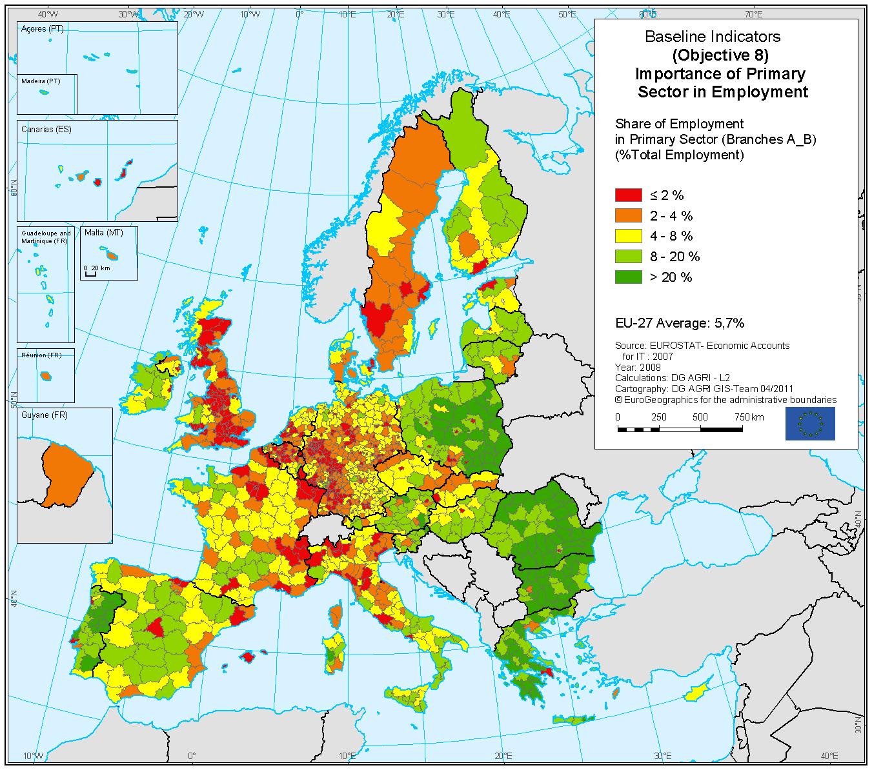
Source: EC, (n.d)

References list
Alexandri, C. (2012) “A food security analysis in a European context” Agricultural Management / Lucrari Stiintifice 14(2): 13-20
Alexandri, C. (2013) “Evaluating the Impact of Future Common Agricultural Policy Options on Farm Incomes and Agricultural Supply” Agricultural Economics and Rural Development 1: 31–49
Al Jazeera (2014) “The hidden hands behind East-West tug of war in Ukraine. Is it in Ukraine’s best interest to negotiate liberalisation with the IMF and the World Bank?” Al Jazeera [online] July-August Available at: <http://www.aljazeera.com/indepth/opinion/2014/07/ukraine-imf-agriculture-2014731945562212.html> [Accessed 11/08/2014]
Avram, C., Radu, R. and Bărbieru, M (2013) “Agrarian Policies in Communist and Post-Communist Romania: Interferences, Discontinuities and Consequences on the Social Development Level” Revista de Ştiinţe Politice/Revue des Sciences Politiques 37-38: 189-200
Barjolle, D., Ghib, M. L. and Larkham, K. (2013) “Small family farms in Romania: How to valorise their goods and services?” Spanish Journal of Rural Development 4(4): 67-78
BBC (2013) “Q&A: Reform of EU farm policy” BBC News [online] 1 July Available at: http://www.bbc.co.uk/news/world-europe-11216061 [Accessed 11/08/2014]
Beilin, R. (2005) “Photo-elicitation and the agricultural landscape: ‘seeing’ and ‘telling’ about farming, community and place” Visual Studies 20(1): 56-68
Bergeron, S. (2001) “Political Economy Discourses of Globalization and Feminist Politics” SIGNS: Journal of Women in Culture and Society 26(4):983-106
Bericat, E. (2011) “Imagen y conocimiento: Retos epistemológicos de la sociología visual” [Images and knowledge: Epistemological challenges of visual sociology] Revista de Metodología de Ciencias Sociales 22: 113-140
Bernstein, H. (1971) “Modernization Theory and the Sociological Study of Development” Journal of Development Studies 7(2):141-160
Biccum, A.R. (2005) “Development and the ‘New’ Imperialism: a reinvention of colonial discourse in DFID promotional literature” Third World Quarterly 26(6): 1005-1020
Bongioanni, M. (2014) “Romania: Land for Sale” World Policy Journal 31(1): 99-105
Born, B. and Purcell, M. (2006) “Avoiding the Local Trap Scale and Food Systems in Planning Research” Journal of Planning Education and Research 26:195-207
Borodyansky, G. (2014) “Russia's small farmers are the latest 'health and safety' victims” The Ecologist [online] 5 August Available at: <http://www.theecologist.org/News/news_analysis/2500727/russias_small_farmers_are_the_latest_health_and_safety_victims.html> [Accessed 11/08/2014]
Bourdieu, P. (1977) “Structures and habitus”: 72-87 in Outline of a theory of practice 1st ed. Cambridge, U.K.: Cambridge University Press
Bowler, I. (1992). The Geography of agriculture in developed market economies. 1st ed. Harlow, Essex, England: Longman Scientific & Technical
Brockmann, M. (2011) “Problematising short-term participant observation and multi-method ethnographic studies” Ethnography and Education 6(2): 229-243
Brow, J. (1996) Demons and development: the struggle for community in a Sri Lankan village 1st ed. Tucson: University of Arizona Press
Burja, C. and Burja, V. (2010) “Sustainable Value Analysis or Romanian Agriculture” Environmental Engineering and Management Journal 9(6): 839-846

Buttel, Frederick H. (n.d.)” Envisioning the future development of farming in the USA: Agroecology between extinction and multifunctionality?” New Directions in Agroecology Research and Education: 1-14 [online] Available at: <http://www.agroecology.wisc.edu/downloads/buttel.pdf> [Accessed 11/08/2014]
Camarero, C., Hernández, C., and San Martín, S. (2007) “Developing relationships within the framework of local economic development in Spain” Entrepreneurship and Regional Development 20: 41–65
Chambers, R. (1983) Rural Development: Putting the last first 1st ed. London: Longman
Chambers, R. and Conway, G.D (1991) “Sustainable rural livelihoods: practical concepts for the 21st century” IDS Discussion Paper 269, December: 1-29
Chambers, R. (1997) Whose reality counts? Putting the last first 1st ed. London: Intermediate Technology.
Cherp, A. (2001) “Environmental assessment in countries in transition: Evolution in a changing context” Journal of Environmental Management 62(4): 357-374
Code of Ethics of the American Anthropological Association. Approved February 2009 [online] Available at: <http://www.aaanet.org/issues/policy-advocacy/upload/AAA-Ethics-Code-2009.pdf> [Accessed 11/08/2014]
Dillon, E. J., Hennessy, T. and Hynes, S. (2010) “Assessing the sustainability of Irish Agriculture” International Journal of Agricultural Sustainability 8 (3): 131-147
EC (2012a) “La Política Agrícola Común. Una asociación entre Europa y los agricultores” [The Common Agricultural Policy. A partnership between Europe and farmers] European Commission, Luxemburg [online] Available at: <http://ec.europa.eu/agriculture/cap-overview/2012_es.pdf> [Accessed 11/08/2014]
EC (2012b) “50 años de Política Agrícola Común. Historia, Evolución y Futuro de la PAC” [50 years of Common Agricultural Policy. History, Evolution and the Future of the CAP] European Commission [online] Available at: <http://www.unionsagrarias.org/50anosPAC/docs/Manual_universitarios_50_anos_PAC.pdf> [Accessed 11/08/2014]

EC (2013) “Overview of CAP Reform 2014-2020”Agricultural Policy Perspectives, Brief N°5, December 2013, European Comission [online] Available at: <http://ec.europa.eu/agriculture/policy-perspectives/policy-briefs/05_en.pdf> [Accessed 11/08/2014]
EC (n.d) “The CAP towards 2020 Legal proposals” DG Agriculture and Rural Development [image online] Available at: http://ec.europa.eu/agriculture/cap-post-2013/legal-proposals/slide-show_en.pdf [Accessed 11/08/2014]
Escobar, A. (1999) “Power and Visibility: Development and the Invention and Management of the Third World” Cultural Anthropology: 428-443
Escobar, A. (2012) Encountering development: The Making and Unmaking of the Third World 1st ed. Princeton, N.J.: Princeton University Press.
Esposito-Fava, A. and Lajarge, R. (2009) “Territorialisation, return or death of agriculture in rural policies? Paper presented at the XXIII ESRS Congress, August 2009, Vaasa, Finland.
Evans, N., Morris, C. and Winter, M. (2002) “Conceptualizing agriculture: a critique of post-productivism as the new orthodoxy” Progress in Human Geography 26(3): 313–332
Gallagher, T. (1995) Romania after Ceaușescu 1st ed. Edinburgh: Edinburgh University Press.
Geană, G. (2006) “The Carpathian Folk Fairs and the Origins of National Consciousness among Romanians” Nationalities Papers 34(1): 91-110
Geertz, C. (1973) The interpretation of cultures: selected essays 1st ed. New York: Basic Books.
Golea, T. (1988) Romania beyond the limits of endurance 1st ed. Miami Beach, Fla.: Romanian Historical Studies
Government of Romania (2005) National Development Plan 2007-2013 [online] Available at: < http://www.fonduri-e.ro/posdru/images/downdocs/ndp0713.pdf> [Accessed 11/08/2014]
Gorton, M., Hubbard, C. and Hubbard, L. (2009) “The Folly of European Union Policy Transfer: Why the Common Agricultural Policy (CAP) Does Not Fit Central and Eastern Europe” Regional Studies 43(10): 1305-1317
Gray, J. (2000) “The Common Agricultural Policy and the Re-Invention of the Rural in the European Community” Sociologia Ruralis 40(1): 30-52
Hall, D., Hirsch, P. and Li, T. (2011). Powers of exclusion 1st ed. Honolulu: University of Hawaiʻi Press.
Harrison, E.A. and Watson, E.E (2012)” Mind the Gap: Disciplinary Dissonance, Gender, and the Environment” Society and Natural Resources: An International Journal 25(9): 933-944
Hay, I. (2000) Qualitative research methods in human geography 1st ed. South Melbourne, Vic.: Oxford University Press
Hubbard, C. and Gorton, M. (2011) “Placing agriculture within rural development: evidence from EU case studies” Environment and Planning C: Government and Policy 29(1): 80-95
Iacono, J., Brown, A. and Holtham, C. (2009) “Research Methods – a Case Example of Participant Observation” Electronic Journal of Business Research Methods 7(1): 39-46
InfoRumania (2007) “Mapa de Rumanía, mapa ciudades y carreteras” [Map of Romania, map cities and roads] [image online] Available at: <http://www.inforumania.com/mapa-rumania.html> [Accessed 11/08/2014]
Iorio, M. and Corsale, A., (2010) “Rural tourism and livelihood strategies in Romania” Journal of Rural Studies 26: 152–162
Jorgensen, D.L (1989) Participant observation: a methodology for human studies 1st ed. Newbury Park, Calif.: Sage Publications
Juler, C. (2014) “După coada oilor: long-distance transhumance and its survival in Romania” Pastoralism: Research, Policy and Practice 4:4 [online] Available at: <http://www.pastoralismjournal.com/content/4/1/4#sec6:> [Accessed 11/08/2014]
Kerekes, K. (2010) “The impact of EU-accession on farming and agricultural employment in Cluj County” Eastern Journal of European Studies 1(1): 45-62
Kligman, G. (1984) “The Rites of Women: Oral Poetry, Ideology, and the Socialization of Peasant Women in Contemporary Romania” The Journal of American Folklore 97(384): 167-188
Komppula, R. (2013) “The role of individual entrepreneurs in the development of competitiveness for a rural tourism destination. A case study” Tourism Management 40: 361-371
Li, T.M. (2011) “Centering labor in the land grab debate” The Journal of Peasant Studies 38(2): 281-298
Macken-Walsh, Á. (2011) “Partnership and subsidiarity? A case-study of farmers’ participation in contemporary EU governance and rural development initiatives” Rural Society 21(1): 43–53
Macken-Walsh, Á. and Curtin, C. (2013) “Governance and Rural Development: The Case of the Rural Partnership Programme (RPP) in Post-Socialist Lithuania” Sociologia Ruralis 53 (2): 246-264
Mallada, L. (1890) Los males de la patria y la futura revolución española [The illnesses of the country and the future Spanish revolution] 1st ed. Madrid: Tip. de M. Ginés Hernández.
Marcu, A.M (2013) “The regional and local distribution of funds allocated by the European Agricultural Fund for Rural Development in Romania” Romanian Review of Regional Studies 9(2): 31-36
Martin, M. and Mesias, F.J. (2002) “Desacoplamiento y Modulación en la Reforma intermedia de la PAC” [Decoupling and Modulation in the mid-term review of the CAP]: 97-110 in Facultad de ciencias económicas y empresariales. Escuela de Ingenierías Agrarias Informe 202: La agricultura y la ganadería extermeñas [2002 Report: Agriculture and cattle in Extremadura] Universidad de Extremadura [online] Available at: <http://www.unex.es/conoce-la-uex/estructura-academica/centros/eia/archivos/iag/2002/2002_00%20indice.pdf> [Accessed 11/08/2014]
Mason, R. (2014) “David Cameron: Romania and Bulgaria immigration levels 'reasonable'” The Guardian [online] 27 January Available at: <http://www.theguardian.com/uk-news/2014/jan/27/cameron-romania-bulgaria-immigration-reasonable> [Accessed 11/08/2014]
McCarthy, J. (2005) “Rural geography: multifunctional rural geographies – reactionary or radical?” Progress in Human Geography 29(6): 773-782
McDonagh, J. (2012) “Rural geography I: Changing expectations and contradictions in the rural” Progress in Human Geography. 37(5): 712-720
McMorran, C. (2012) “Practising workplace geographies: embodied labour as method in human geography” Area 44(4): 489–495
McNamara, R.S. (1975) “Preface” in World Bank The Assault on world poverty: problems of rural development, education, and health Baltimore, United States of America: the World Bank by the Johns Hopkins University Press
McQuire, S. (2013) “Photography’s afterlife: Documentary images and the operational archive” Journal of Material Culture 18(3): 223–241
Nica, M. (2013) “Austrian company drafts Romania’s rural development” Agricultural and Rural Convention (ARC 2020) [online] 27 August Available at: <http://www.arc2020.eu/front/2013/08/austrian-company-secures-3-5-million-to-manage-romanian-rural-development/> [Accessed 11/08/2014]
Niculescu, O.M. (2012) “Common Agricultural Policy Post-2013 in the View of Romania and France” Annals of the University of Oradea, Economic Science Series 21(1): 144-149
Nourish Scotland (2013) “Feeding the five million” Conference Report, October 2013 Edinburgh, Scotland
Oliva, J. (1997) “Estructuración y restructuración de espacios y sociedades rurales: nuevas reflexiones sobre unos procesos no esperados” [Structuration and restructuration of spaces and rural societies: new reflections about some non-expected processes] Zainak 14: 321-337
Oliva, J. (2006) “Movilidad laboral y estrategias de arraigo rural” [Labour mobility and rural roots strategies] Revista Espanola de Estudios Agrosociales y Pesqueros 211: 143-187
Ortega Olivares, Mario (2009) “Metodología de la Sociología Visual y su Correlato Etnológico” [Methodology of the Visual Sociology and its Ethnologic Correlate] Nueva Época 22(59):165-184
Osti, G. (2000) “LEADER and Partnerships: The Case of Italy” Sociologia Ruralis 4 (2): 172-180
Otiman, P.I., Toderoiu, F., Florian, V., Alexandri, C., Gavrilescu, C., Ionel, I., Grodea, M., Alboiu, C., Moldovan, M., Goşa, V. and Nagy, A. (2010) “Agriculture And Rural Development In Romania – The Main Modalities To Attenuate The Crisis Effects And To Resume Economic Growth” Working Papers of the Institute of Agricultural Economics, Institute of Agricultural Economics [online] Available at: <http://econpapers.repec.org/paper/iagwpsiea/101101.htm> [Accessed 11/08/2014]
Peet, R. and Watts, M. (1993) “Development Theory and Environment in an Age of Market Triumphalism” Economic Geography 69(3): 227-253
Peet, R. (2002) “Ideology, Discourse and the Geography of Hegemony: From Socialist to Neo-liberal Development in Post-Apartheid South Africa” Antipode 34(1):54-84
Potter, C. and Tilzey, M. (2005) “Agricultural policy discourses in the European post-Fordist transition: neoliberalism, neomercantilism and multifunctionality” Progress in human geography 29(5): 581-600
Rabhi, P. (2011) “Pierre Rabhi: ‘Vivre sobrement, c'est une forme de libération’” [Pierre Rabhi: To live soberly, it is a form of release] Le Monde [online] 3 June Available at: <http://www.lemonde.fr/planete/article/2011/06/03/pierre-rabhi-vivre-sobrement-c-est-une-forme-de-liberation_1531614_3244.html> [Accessed 11/08/2014]
Radcliffe, S., Laurie, N. and Andolina, R. (2002) “Re-territorialized Space and Ethnic Political Participation: Indigenous Municipalities in Ecuador” Space and Polity 6(3):289-305
Roca, L. (2012) “Investigación social con imágenes. Revisión de una búsqueda Interdisciplinaria” [Social research with images. Review of an Interdisciplinary approach] Contrafoco Imagen y Ciencias Sociales 1(1): 1-16
Rose, G. (2012) Visual methodologies. An introduction to the interpretation of visual materials 1st ed. London: SAGE
Rusu, M. and Florian, V. (n.d) “Rural space and rural development in Romania” Rural Areas and Development 1: 39-55 [online] Available at: <http://ideas.repec.org/a/ags/erdnra/122655.html> [Accessed 11/08/2014]
Salazar, C. (1996) A sentimental economy: commodity and community in rural Ireland 1st ed. Providence, RI: Berghahn Books
Scoones, I. (2009) “Livelihoods perspectives and rural development” The Journal of Peasant Studies 36(1): 171-196
Sharp, J., Campbell, P. and Laurie, E. (2010) “The Violence of Aid? Giving, Power and Active Subjects in One World Conservatism” Third World Quarterly 31(7):1125-1143
Shiva, V. (2004) “Earth Democracy Creating living economies, living democracies, living cultures” South Asian Popular Culture 2(1): 5–18
Sîrbu, G. (n.d) “Rural Development Issues in Romania” [Powerpoint presentation] Ministry of Agriculture and Rural Development n.l [online] Available at: <http://www.oecd.org/tad/agricultural-policies/39275675.pdf> [Accessed 11/08/2014]
Sîrbulescu, A. and Sîrbulescu, C. (2011) “Perspectives of agricultural holdings in Romania and means of adaptation to European Union requirements” Agricultural Management / Lucrari Stiintifice 13(1): 327-332
Slater, David (1993) “The Geo-Political Imagination and the Enframing of Development Theory” Transactions of the Institute of British Geographers 18(4):419-437
Sutton, M. and Anderson, E. (2004). Introduction to cultural ecology 1st ed. Walnut Creek, CA: AltaMira Press.
Sylvester, C. (1999) “Development studies and postcolonial studies: disparate tales of the ‘Third World’’ Third World Quarterly 20(4): 703-721
Thorpe, N. (2007) “EU clash with Romanian tradition” BBC News [online] 27 January Available at: <http://news.bbc.co.uk/1/hi/programmes/from_our_own_correspondent/6303371.stm> [Accessed 11/08/2014]
Vişan, S. and Căpraru, A.M. (2012) “Management Aspects Regarding the Market of Organic Products in Romania” Review of International Comparative Management 13(3): 436-448
Voiculescu, C. (2008) “Disappearing peasants? On land, rent, and revenue in post-1989 Romania” European Journal of Anthropology 52: 77-91
Wallerstein, I. (1993) “The World-System after the Cold War” Journal of Peace Research 30(1): 1-6
Watts, D.C.H., llbery, B. and Maye D. (2005) “Making reconnections in agro-food geography: alternative systems of food provision” Progress in Human Geography 29(1): 22-40
Wright, M.W. (1997) “Crossing the factory frontier: gender, place, and power in the Mexican Maquiladora” Antipode 29(3): 278-302
Woods, M. and McDonagh, J. (2011) “Rural Europe and The World: Globalization and Rural Development” European Countryside 3(3): 153-163
Zagoni, A., Mănescu, C. and Mateoc-Sîrb, N. (2012) “Possibilities to Use the Renewable Energies in Arad County” Agricultural Management / Lucrari Stiintifice 14(1): 433-440
Zahle, J. (2012) “Practical Knowledge and Participant Observation” Inquiry: An Interdisciplinary Journal of Philosophy 55(1): 50-65
Websites:
European Commission (2014) Website: <http://enrd.ec.europa.eu/enrd-static/policy-in-action/cap-towards-2020/rdp-programming-2014-2020/en/rdp-programming-2014-2020_en.html> [Accessed 11/08/2014]
Eco Ruralis Website: <http://www.ecoruralis.ro/web/en/Programs_and_Activities/Land_Issues_and_Access_to_Land/> [Accessed 11/08/2014]
Land Matrix Website: <www.landmatrix.org> [Accessed 11/08/2014]
World Bank database: < http://data.worldbank.org/> [Accessed 11/08/2014]

European Union’s Former Commissioner for Agricultural and Rural Development
Initially by and in East Germany, Belgium, France, Italy, Luxembourg and the Netherlands.
There are important regional differences. Belgium for instance has 2.5% of rural population whereas Romania amounts 47% (WB database). Furthermore, new trends of urban-rural migrations might be necessary to consider in the near future.
Since I will not use this term as a rhetorical element or a concept of debate, throughout this dissertation I will refer to “countryside” as an equivalent to “rural areas”.
Although the new reform might equate them.
Furthermore, the 2014-2020 NPRD for Romania is being prepared by an Austrian company (Nica, 2013).
In addition to the CAP payments, national governments are in charge of adding a supplementary percentage of their state budgets for agricultural and rural development at the national level (Otiman et al., 2010). Needless to say that the potential of the different countries is very different.
Bowler (1992) advises to be careful with percentages, because when accumulated, they do not show the regional differences.
In these terms, the UK supports the full liberalisation of the CAP, now (see Niculescu, 2012).
During the transition period (early 90’s) imports reached more than 80% of the internal consumption, making from the country a net agro-food importer (Sîrbu, n.d), although the country has a great agricultural potential. The reasons are diverse (see Otiman et al., 2010; Avram, Radu and Barbieru, 2013; Barjolle, Ghib and Larkham, 2013)
Since the United Nations Conference on Environment and Development in Rio 1992, the principle of sustainability became a major within rural development strategies. Sustainability embeds three dimensions: economic, social and environmental security and justice. It was promoted in order to avoid prioritizing economic growth at the expenses of the social and environmental degradation (Dillon, Hennessy and Hynes, 2010).
The SAPS has given almost nothing to small-holdings. Most of them do not comply with the minimum required hectares to access these payments, 1 hectare of farm and 0.30 hectares of individual plots (Barjolle et al., 2013).
Furthermore, authors such as Evans et al., (2002) consider the post-productivist concept poorly developed and too simplistic to define a series of important changes within agrarian societies.
Different articles point out to different areas such as the West; however, doing my fieldwork, I was reaffirmed that this was happening in the south. It seems that there is confusion in terms of land acquisitions and agribusiness expansion. The data of the Land Matrix website do not seem complete in Romania (www.landmatrix.org).
Rural tourism raised 5.8 times between 1998 and 2003 (Government of Romania, 2005).
Although its natural potential tends to be highly valued.
It is necessary to comment that the language barrier was an issue, but it was less than expected because of two main reasons: first, at least half of the people closest to me were able to speak a language that I could understand (Spanish, English or French). Second, because those who did not speak any other language a part from Romanian, would make the effort, and with patience, basic communication was feasible between me and them.
An example of this is that, as I was told, some women became more subservient to their husbands when I was present.
This also minimized the barrier observer-observed including peoples within (and not only in) my research (Roca, 2012; McQuire, 2013).
Which corresponds to the NUTS 5 level of the territorial statistical system of the EU (Rusus and Florian, N.Y).
I want to remind that I am not talking about Romania in general in this chapter. The data are site-specific.
It might be of interest accounting that, since I was grown in a town of 200.000 inhabitants, I could be perceiving the rural world as something exaggeratedly “exotic”. However, during my life, I have spent large seasons in Western rural areas. These are not unfamiliar or new worlds to me.
I will try to avoid the concept of poverty. The people that I met during my fieldwork never referred to themselves as “poor”. At most, they said that they did not have much money or that their conditions were not the best; they considered poor to the people who begs in the street. Therefore, it does not correspond to me giving them this denomination. As Chambers says, we should not overextend the concept of “poverty” carelessly (1983).
Among the people that I met, three families had 7, 9 and 9 children respectively. Big families were common.
The houses inside the household tended to be small in the inside. I saw horses and cows almost bigger than the hut where they were.
Here tasks are much defined according to gender. Women deal with the household. Meanwhile, men are more present in the public sphere.
It is not a real reward, it is more related to tacit friendly coexistence.
Before the ceremony, the bride, the groom, and the wedding entourage walk arround the village offering Țuică and listening to music. They told me that the bride was 21. My peers got married when she was 18. They usually get married early. In fact, everybody was quite surprised that I was not, being 24.
Although, Chambers (1983) and Oliva (2006) claim that rural inhabitants are never considered professionals.
Expected to gain further relevance in the period 2014-2020
Since Romania’s EU accession, the internal regulated market has to conform with European regulations as well.
Another example of agrarian policies negatively affecting the small farmers on the name of animal welfare standards is the one by Borodyansky (2014) in Russia.
For further information about local markets and its social functions see Geana (2006) and Juler (2014)
Lauded Romanian academic and political adviser.
Head of the Food Safety Inspectorate in Bucharest in 2007. The sentences in italics are their own statements. The others are from the journalist Nick Thorpe.
For an interesting example in Ukraine: http://www.aljazeera.com/indepth/opinion/2014/07/ukraine-imf-agriculture-2014731945562212.html.
Cross Compliance: Farmers applying for these payments who do not comply with certain requirements in the areas of public, animal and plant health, environment and animal welfare are subject to reductions of or exclusion from this direct support (EC, 2013).
The measures of the new reform for the period 2014-2020 have not yet been launched.

